|  |  |
| --- | --- |
|  | **VIỆN ĐÀO TẠO QUỐC TẾ FPT**  **LẬP TRÌNH VIÊN QUỐC TẾ** **FPT – APTECH**  **Centre Name: ACE-HCMC-2-FPT.**  **Address: 590 Cach Mang Thang 8, District 3, Ho Chi Minh City, Viet Nam.** |

**TourViet**

Design Document

|  |  |  |  |
| --- | --- | --- | --- |
| **Faculty:** | **Tran Phuoc Sinh** | |  |
| **Batch No:** | F2-T1.2109.M1 | |  |
| **Group No:** | 03 | |  |
| **Students:** |  | **Full Name** | **Roll No.** |
|  | 1. | Tran Cong Thinh | Student1331708 |
|  | 2. | Huynh Ngoc Thai | Student1317113 |
|  | 3. | Hoang Quoc Vinh | Student1331702 |
|  | 4. | Nguyen Anh Phu | Student1318433 |
|  | 5. | Nguyen Dinh Duc | Student1331704 |

# **Table of Contents**

**Table of Contents 2**

**Acknowledgements 6**

**1. Overview 8**

1.1 Project Information 8

1.2 Product Background 8

1.3 Existing Systems 9

1.4 Business Opportunity 9

1.5 Project Scope & Limitations 10

**2. User Requirements 11**

2.1 Actor 11

2.2 High-level Use Case 12

2.3 Use Case List 13

2.4 Use Case & Actor mapping 15

**3. Management Plan 17**

3.1 Scope and Estimation 17

3.2 Management Approach 19

3.3 Training Plan 20

**4. System Requirements 20**

4.1 Hardware Requirement 20

4.2 Software Requirements 20

4.3 Technology Summary 21

**1. Architecture Design 24**

**2. Use Case and Sequence Diagram 25**

3**. Table Definition 65**

4**. Relational Schema**

**87**

**2. Web GUI Design**

**91**

**3. Mobile GUI Design 119**

# 

# **Acknowledgements**

The satisfaction that accompanies the successful completion of any task would be incomplete without the mention of people whose ceaseless cooperation made it possible, whose constant guidance and encouragement crown all efforts with success.

We are grateful to our project guide Mr. Tran Phuoc Sinh for the guidance, inspiration, and constructive suggestions that helped us in the preparation of this project.

We also thank our colleagues who have helped in successful completion of the project.

**REVIEW** **1**

# **1. Overview**

## 1.1 Project Information

* Project name: Tour Viet
* Group name: group 03
* Software type: Web Application, Mobile Application

## 1.2 Product Background

Designing and developing a web and mobile application for tourist involves several stages of production. Here's a brief overview of the production background for such a project:

Requirement gathering: This stage involves identifying the requirements of tourist for the application. It is essential to gather feedback from users to determine the features and functionality that should be included in the application.

Design: Once the requirements are clear, the design phase begins. It includes creating the visual design of the application and defining the user interface and user experience. A prototype may be developed to get feedback from users.

Development: This phase involves the actual development of the application. The development team will use the appropriate technology stack to build the application, and the features identified in the design stage will be implemented.

Testing: Before the application is released, it must be thoroughly tested to ensure that it meets the requirements and functions as expected. Various types of testing, including functional, performance, and security testing, should be conducted.

Deployment: Once the application is tested and approved, it is deployed to the production environment. This involves setting up servers, configuring the database, and other technical tasks.

Maintenance and support: After the application is deployed, it is important to provide ongoing maintenance and support to ensure that it continues to function correctly. Bug fixes, updates, and improvements may be required over time.

## To create a travel web project and mobile app, it will need to consider the specific features and functionality that travelers require. This can include booking travel tours, remote support features for travelers, storing memories on a profile, and secure messaging systems.

## 1.3 Existing Systems

There are several existing systems for tourist web and mobile application projects that we can consider when developing your own app. Here are a few examples:

Expedia: Expedia is one of the largest online travel agencies in the world. They offer flight bookings, hotels, tours and all-inclusive accommodation packages.

Airbnb: Airbnb is a platform for short-term rentals of accommodation, including apartments, private homes, and rooms in other people's homes. You can find accommodation to suit your needs in more than 191 countries.

Viator: Viator is an online tour booking system that specializes in activities and tours in various destinations around the world. They offer a wide range of unique tours and special experiences.

Tripadvisor: Tripadvisor is not only a hotel and restaurant review website, it also offers tour booking services. You can search, compare and book tours through their platform.

Kayak: Kayak is a powerful travel search engine that allows you to compare airfares, hotels, rental cars, and tours from a variety of websites.

When developing our own tourist web and mobile application project, we can take inspiration from these existing systems and incorporate features and functionalities that are relevant to your target audience. It's important to conduct thorough research and identify the unique needs and pain points of your users to ensure that your application is successful.

## 1.4 Business Opportunity

The tourism industry offers a variety of business opportunities. Here are some facts about business opportunities in the tourism industry:

Hotel and accommodation booking: Business in hotel and accommodation booking can be very promising. You can build an online booking website, develop a mobile app or provide booking services for hotels and motels.

Tours and Recreation: Organizing tours and recreational activities is an attractive business opportunity. You can create unique tours, including city tours, nature tours, cultural tours, or recreational activities like rock climbing, scuba diving, exploration, and more.

Tour guide service: If you have in-depth knowledge of a particular tourist destination, you can become a tour guide and provide guide services for tourists. You can create custom tours based on customer preferences or offer guided services in popular tourist areas.

Travel transportation services: Another business opportunity is to provide travel transportation services. You can open a transportation company, provide airport transfers, rent a car, or create special transportation services for customers.

Food guide services: Culinary tourism is growing in popularity and can create exceptional business opportunities. You can organize food tours, experience cooking, or provide food guide services to showcase the unique food culture of a place.

Tourism support services: In addition to direct activities with tourists, there are many business opportunities in the field of tourism support services. This includes travel advisory services, travel insurance services, visa and reference assistance services, itinerary transfer services and language assistance services.

A tour booking website can bring many advantages in terms of attractive features for users. Here are some key points:

* Easily search and book tours
* Tour details
* Reviews and customer reviews
* Announcements and updates
* Customer support

## 1.5 Project Scope & Limitations

A tour web project can require many complex elements and features to serve users in the best way. However, here are some of the common limitations encountered in tour projects:

* No actual service: A tour website is usually just a platform for information and booking. However, it cannot provide a realistic travel experience to the user. Participation in actual travel, travel and exploration activities depends on the customer and other service providers.
* Limited quality control: While a tour website may display reviews and comments from past customers, it is difficult to control the actual quality of tours. This depends on the capabilities of the service providers and the individual customer experience.
* Customization restrictions: Some tour sites may have limitations on the ability to customize tours. While several choices and variations can be offered, it is not possible to accommodate every individual customer's customization requirements.
* Limited look and feel: Tour websites may have limited looks and designs. This may degrade the user experience or not satisfy some special requirements.
* Limited customer support: Some tour sites may not offer comprehensive customer support channels or slow response times.
* Payment feature limitations: A tour web project may struggle to integrate complex payment forms or support special payment processes.

# **2. User Requirements**

## 2.1 Actor

|  |  |  |
| --- | --- | --- |
| **#** | **Actor** | **Description** |
| 0 | **Tourist (User)** | Normal users after successfully logging in to the mobile application can book travel and use all the services provided. |
| 1 | **Area(Staff)** | Area also known as employee, as an advanced user, can login to the management console. A Area that can text with tourists |
| 2 | **HQ (Staff)** | HQ also known as employees, as advanced users, can log in to the management console. A HQ can text with Area. He/she can access many other advanced features (eg Area management, tour guide management,...). |
| 3 | **Super Admin** | The administrator has all the features of a staff. In addition, an administrator has almost full control of the system. Administrators can add new physician/staff and manage invoices. |
| 4 | **Tour Guides (Staff)** | Tour guides are also known as staff, whose main function is to message the people on the tour they manage. |

## 2.2 High-level Use Case

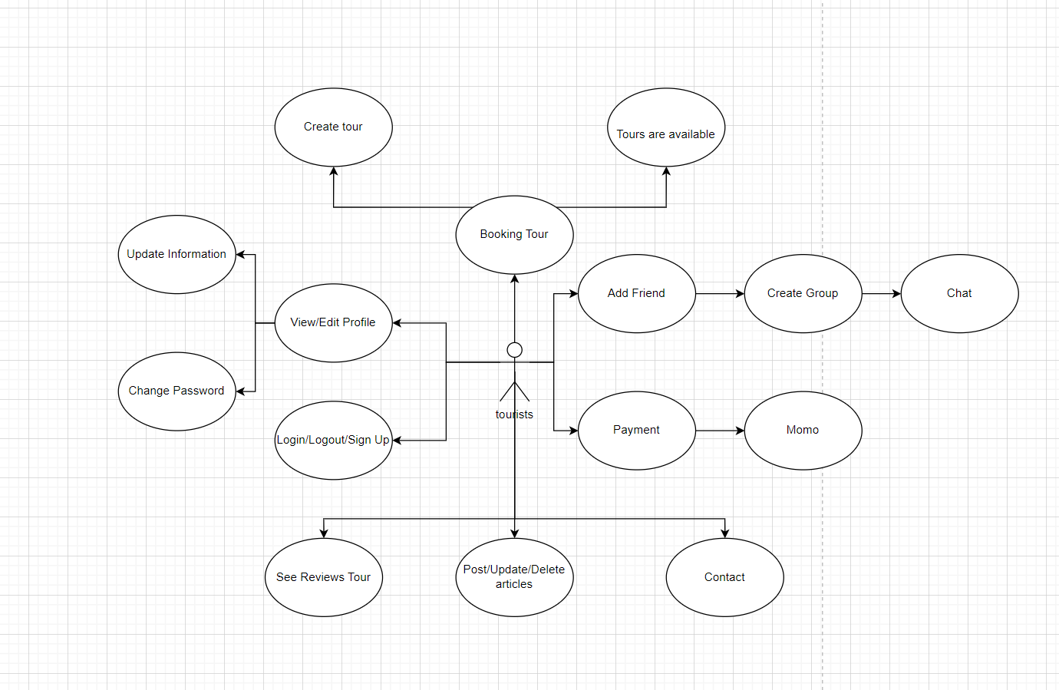

Tourist’s functionalities

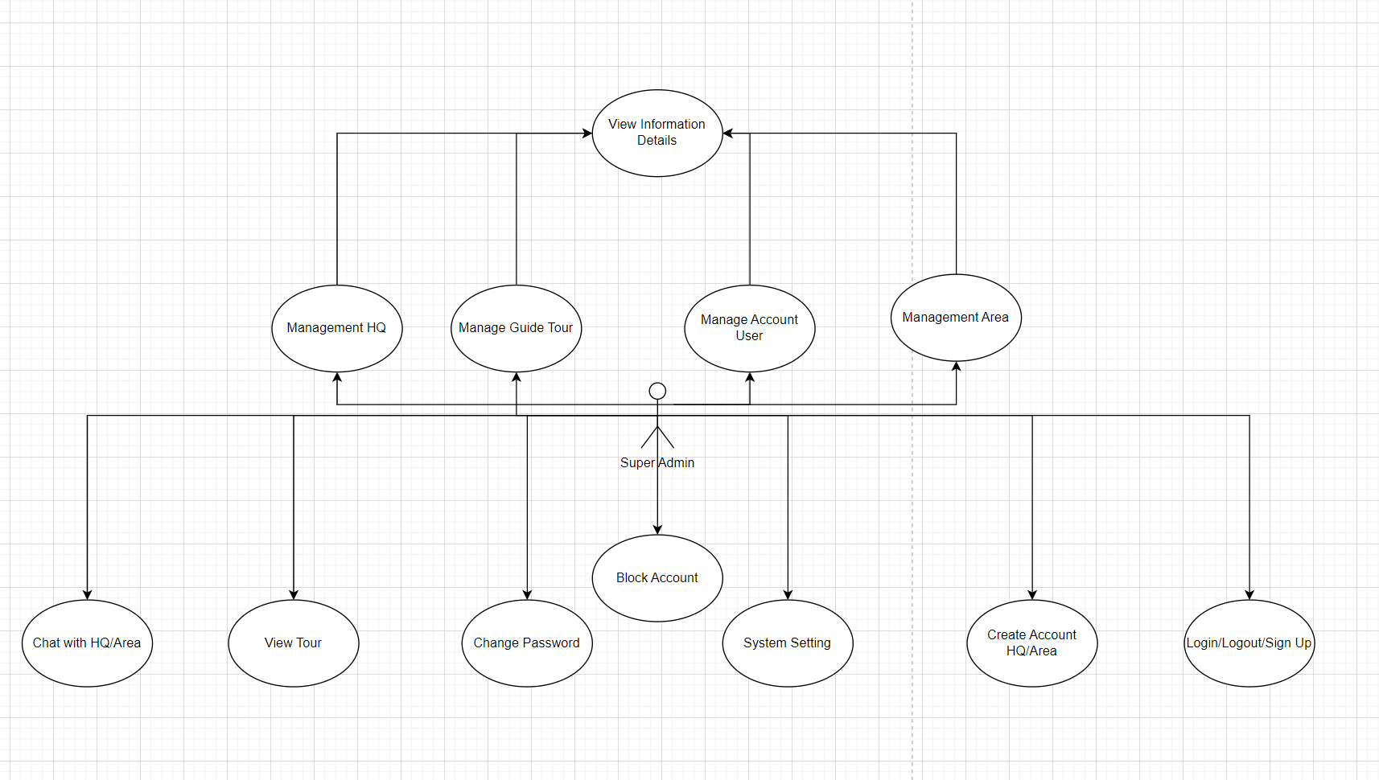

SuperAdmin’s functionalities

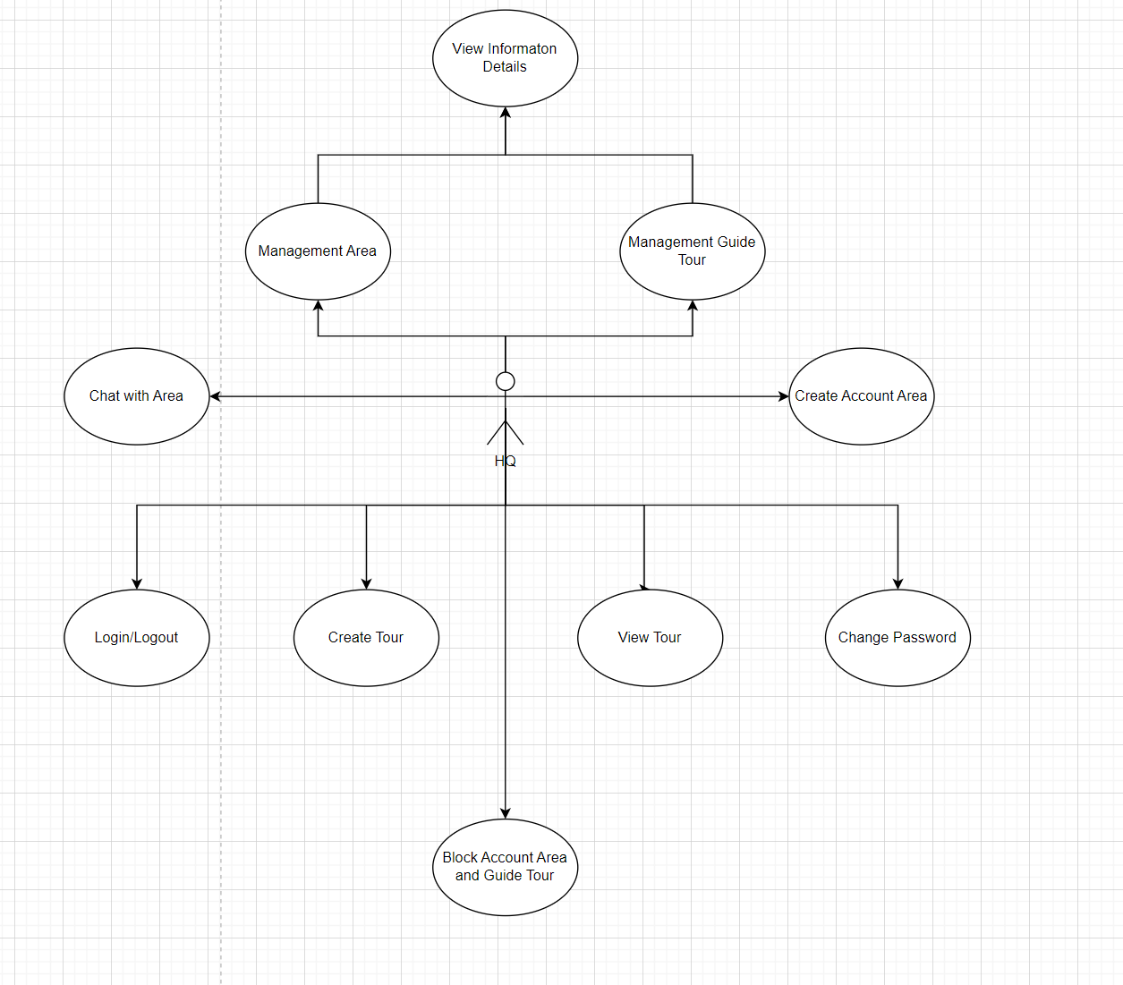

HQ’s functionalities

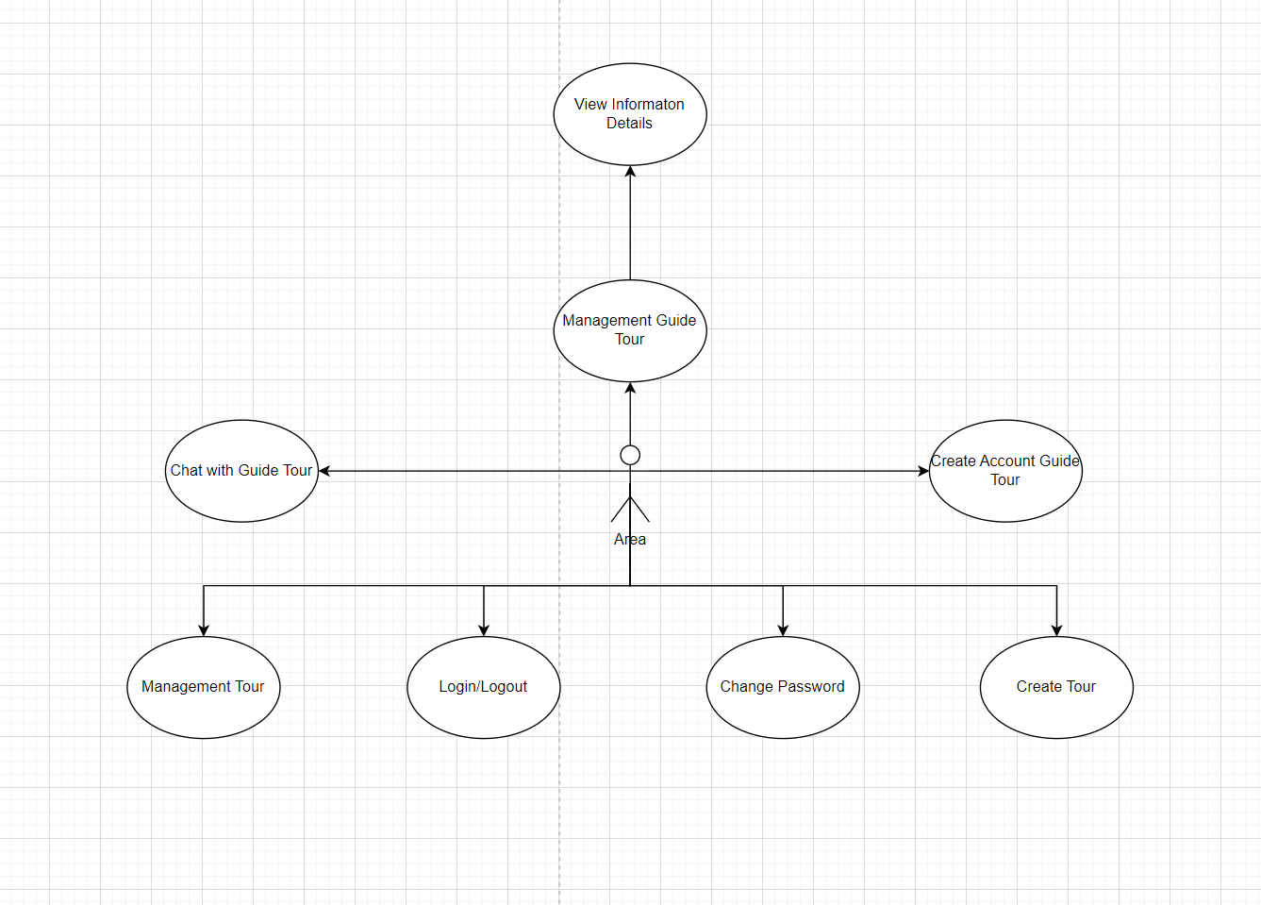

Area’s functionalities

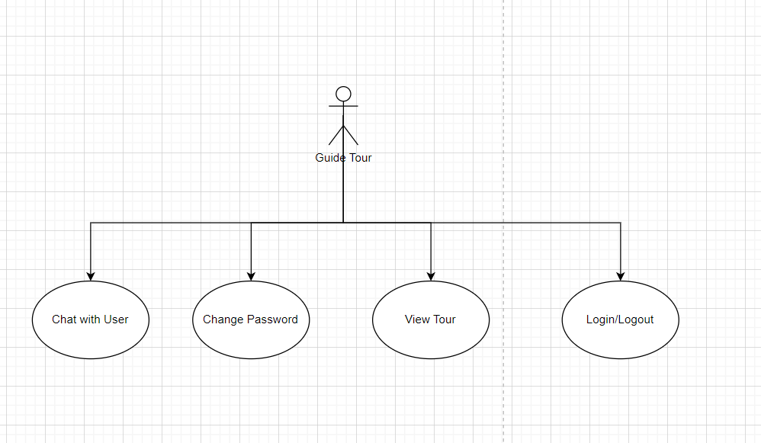

Guide Tour’s functionalities

## 2.3 Use Case List

|  |  |  |  |
| --- | --- | --- | --- |
| **#** | **Code** | **Name** | **Description** |
| 1 | UC101 | **Login** | Login with email and password or social identity provider (Google) |
| 2 | UC102 | **Logout** |  |
| 3 | UC103 | **Change password** |  |
| 4 | UC104 | **Forgot password** |  |
| 5 | UC105 | **View Tour** |  |
| 6 | UC106 | **In-app Notification** | Realtime notification for web/mobile application |
| 7 | UC107 | **View Profile** | Show personal information (first name, last name, email, date of birth, avatar,phone,...) |
| 8 | UC108 | **Edit Profile** | Change personal information |
| 9 | UC109 | **Message** |  |
| **HQ(Staff)** | | | |
|  | UC201 | **View / Search Area and Tour Guide** | List all staffs, search for staffs |
|  | UC202 | **Management Account** | Show detail information of area and guide tour |
|  | UC203 | **Add Area** | Add new Area |
|  | UC204 | **Block Account** | Block account Area and Guide Tour |
|  | UC205 | **Create Tour** | Create tour in area |
|  | UC206 | **Chat** | Chat with area |
| **Tourist** | | | |
|  | UC401 | **Booking tour** | Users create their own tours or search tours are available |
|  | UC402 | **Details tour** | Show information tour |
|  | UC403 | **Add Friend** | Add your friend |
|  | UC404 | **Your article** | Post , Update, Delete article |
|  | UC405 | **See review tours** | List all review tour are available |
|  | UC406 | **Chat** | Chat with your friend and guide tour |
| **Area(Staff)** | | | |
|  | UC501 | **Add Tour** | Add tour in area |
|  | UC502 | **Manage Account** | Management account for guide tour |
|  | UC503 | **Management tour** |  |
|  | UC504 | **Chat** | Chat with guide tour |
| **Super Admin** | | | |
|  | UC601 | **Management Account** | Management account all |
|  | UC602 | **Block account** | Block all account without super admin |
|  | UC603 | **Chat** | Chat with HQ and area |
|  | UC604 | **Create account** | Create account for HQ and area |
|  | UC605 | **Management System** |  |
| **Guide Tour** | | | |
|  | UC701 | **Chat** | Chat with area and tourist |

## 2.4 Use Case & Actor mapping

|  |  |  |  |  |  |  |
| --- | --- | --- | --- | --- | --- | --- |
| **Actor**  **Use Case** | | **Super Admin** | **HQ** | **Area** | **Guide Tour** | **Tourist** |
| UC101 | **Login** | x | x | x | x | x |
| UC102 | **Logout** | x | x | x | x | x |
| UC103 | **Change password** | x | x | x | x | x |
| UC104 | **Forgot password** | x | x | x | x | x |
| UC105 | **View Tour** | x | x | x | x | x |
| UC106 | **In-app Notification** | x | x | x | x | x |
| UC107 | **View Profile** | x | x | x | x | x |
| UC108 | **Edit Profile** | x |  |  |  | x |
| UC109 | **Message** | x | x | x | x | x |
| UC201 | **View / Search Staffs** | x | x |  |  |  |
| UC202 | **Management account** | x | x |  |  |  |
| UC203 | **Create account** | x | x |  |  | x |
| UC204 | **Block account** | x | x |  |  |  |
| UC401 | **Booking tour** | x | x | x |  | x |
| UC403 | **Add friend** |  |  |  |  | x |
| UC404 | **Your article** |  |  |  |  | x |
| UC405 | **See review tour** | x | x | x | x | x |
| UC501 | **Add tour** |  | x | x |  |  |
| UC605 | **Management System** | x |  |  |  |  |

# **3. Management Plan**

The project started on 14 March and will be handed over on 18 April, so overall there will be ***5 weeks*** for planning, training, and implementation.

## 3.1 Scope and Estimation

|  |  |  |  |  |
| --- | --- | --- | --- | --- |
| **#** | **WBS Item** | **Due Date** | **Complexity** | **Est. Effor (days)** |
| **1** | **Requirement and Planning** | | | **12** |
| 1.1 | Project Plan |  | Medium | 0.5 |
| 1.2 | Traning Plan |  | Medium | 0.5 |
| 1.3 | Review 1 - introduction and Plan |  | Medium | 1 |
| 1.4 | Review 2 - System Design |  | Medium | 1 |
| 1.5 | Review 3 - Product Specification |  | Medium | 2 |
| 1.6 | Overall testing, system integration, documentations (user guide, installation guide) |  | Medium | 6 |
| 1.7 | Brief demo |  | Low | 1 |
| **2** | **Design** | | | **3** |
| 2.1 | Design User interface (UI) prototypes |  | Medium | 2 |
| 2.2 | Overal System diagram |  | Low | 0.2 |
| 2.3 | Write Use Case diagram |  | Medium | 0.2 |
| 2.4 | Draw Flow diagram |  | Medium | 0.2 |
| 2.5 | Entity Relation diagram (ERD) |  | Medium | 0.2 |
| 2.6 | Draw Class diagram |  | Medium | 0.2 |
| **3** | **Implementation** | | |  |
| **3.1** | **Database** | | | **1** |
| 3.1.1 | Implement database from the document (write SQL) |  | Low | 1 |
| **3.2** | **Authorization and Authentication** | | |  |
| 3.2.1 | Setup Authentication & Authorization for microservices (Auth0 integration) |  | High | 1 |
| 3.2.2 | Auth0 Login Page (for mobile app & web app) |  | High |  |
| 3.2.3 | Logout |  | High |  |
| 3.2.4 | Sign in/up hook |  | High |  |
| **3.3** | **API Service** | | |  |
| 3.3.1 | Setup monolith API repository |  | High |  |
| 3.3.2 | Config maven build/test/deploy lifecycle |  | Low |  |
| 3.3.3 | Setup Gitlab work |  | High |  |
| 3.3.4 | Account API(s) |  | High | 0.5 |
| 3.3.5 | Booking API(s) |  | Medium | 0.5 |
| 3.3.6 | Static Data API(s) |  | High | 0.5 |
| 3.3.7 | Staff API(s) |  | High | 0.5 |
| 3.3.8 | Schedule API(s) |  | Medium | 0.5 |
| 3.3.9 | Payment API(s) |  | Medium | 1 |
| 3.3.10 | Super Admin API(s) |  | Medium | 2 |
| 3.3.11 | Setup Notification monolothic (for both in-app notification and email notification) |  | High |  |
| 3.3.12 | In-app notification (using Firebase FCM) |  | High | 1 |
| 3.3.13 | Email notification (using email provider like MailGun) |  | High | 1 |
| **3.4** | **Web App** | | |  |
| 3.4.1 | Register |  | High |  |
| 3.4.2 | Login |  | High |  |
| 3.4.3 | Home |  | High |  |
| 3.4.4 | Admin |  | High |  |
| 3.4.5 | Booking |  | Medium |  |
| 3.4.6 | Detail tour |  | Low |  |
| 3.4.7 | Language |  | High |  |
|  |  |  |  |  |
| **3.5** | **Mobile App** | | |  |
| 3.5.1 | Splash |  | High |  |
| 3.5.2 | Onboard-1 |  | High |  |
| 3.5.3 | Onboard-2 |  | High |  |
| 3.5.4 | Onboard-3 |  | High |  |
| 3.5.5 | Login |  | High |  |
| 3.5.6 | Forgot Password |  | High |  |
| 3.5.7 | Verify Password |  | High |  |
| 3.5.8 | Register |  | High |  |
| 3.5.9 | Terms of Service |  | High |  |
| 3.6.0 | Account |  | High |  |
| 3.6.1 | Home |  | High |  |
| 3.6.2 | Not found |  | Low |  |
| 3.6.3 | Filter |  | Low |  |
| 3.6.4 | Explore |  | Low |  |
| 3.6.5 | Destination |  | Low |  |
| 3.6.6 | Policy |  | Low |  |
| 3.6.7 | Review |  | Low |  |
| 3.6.8 | Gallery |  | Low |  |
| 3.6.9 | Video |  | Low |  |
| 3.7.0 | Create Booking |  | Low |  |
| 3.7.1 | Note |  | Low |  |
| 3.7.2 | Payment |  | Low |  |
| 3.7.3 | Susccess |  | Low |  |
| 3.7.4 | Message |  | Low |  |
| 3.7.5 | Profile |  | Low |  |
| 3.7.6 | Edit |  | Low |  |
| 3.7.7 | Account and Setting |  | Low |  |

## 3.2 Management Approach

Applying the DevOps model to management enables the SPD team to implement the product with effective coordination among development team members.

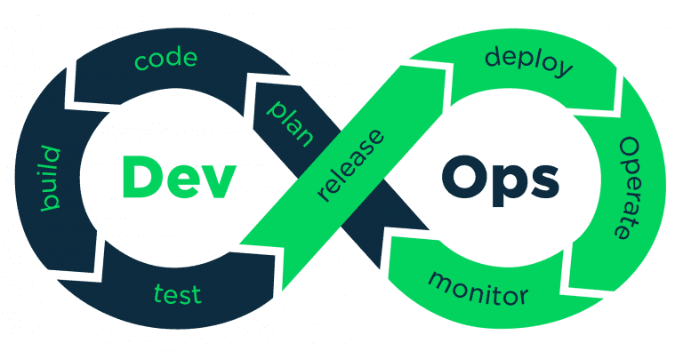

*DevOps lifecycle*

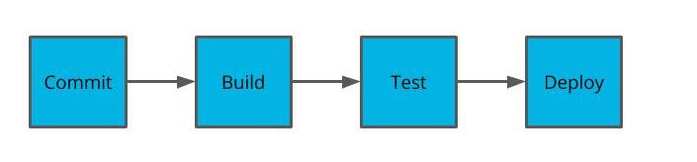

*Deployment pipeline*

## 3.3 Training Plan

|  |  |  |  |
| --- | --- | --- | --- |
| **Training Area** | **Participants** | **When, Duration** | **Waiver Criteria** |
| Api for Spring Boot | Vinh, Đức | Week 1, 3 days | Mandatory |
| Git, Github, Gitlab | All members | Week 1, 1-day | Mandatory |
| DrawIO | All members | Week 1, 1-day | Mandatory |
| Thymleaf | Thái, Phú | Week 2, 3 days | Mandatory |
| Dart, Flutter | Thịnh | Week 2, 3 days | Mandatory |

# **4. System Requirements**

## 4.1 Hardware Requirement

* AMD Opteron, AMD Athlon 64, intel Xeon with intel EM64T support, intel Pentium IV with EM64T support or faster
* Processor Speed 2.0Ghz or faster
* 4G of RAM or higher. (8 GB recommended)
* Hard disk requirement: minimum 50GB
* Windows 10, or windows server 2016 or higher
* Snapdragon 2xx or higher
* Can connect to internet

## 4.2 Software Requirements

* Postgres database
* intelliJ Community 2023 / Apache Netbeans 11 or above
* Maven 3 CLI
* Java Development Kit (JDK) 17 or higher
* No web server requirement (Spring built-in Tomcat server)
* Visual Studio Code (with Dart + Flutter extension)
* Flutter SDK (stable version 3.x.x)
* Android / IOS virtual devices
* Spring Boot (3.x.x)
* Google Chrome

## 4.3 Technology Summary

* Web Application: Thymleaf
* Mobile Application: Flutter
* BackEnd APIs: Spring Boot, SQL Server

Task Sheet 1

|  |  |  |  |  |  |
| --- | --- | --- | --- | --- | --- |
| **Members Group** | | **Date Preparation of Activity Plan** | | | |
| **No** | **Name** | **Description Task** | **Start Date** | **End Date** | **Status** |
| 1 | Hoang Quoc Vinh | High-level use case |  |  | complete |
| User Case list |  |  | complete |
| Management Plan |  |  | complete |
| 2 | Nguyen Anh Phu | Use Case & Actor mapping |  |  | complete |
| 3 | Tran Cong Thinh | Product Overview |  |  | complete |
| Huynh Ngoc Thai |  |  | complete |
| 3 | Nguyen Dinh Duc | System Requirements |  |  | complete |
|  | | | | | |
| **Teacher** | | | **Team Leader** | | |
|  | | |  | | |
|  | | |  | | |

**REVIEW 2**

# **1. Architecture Design**

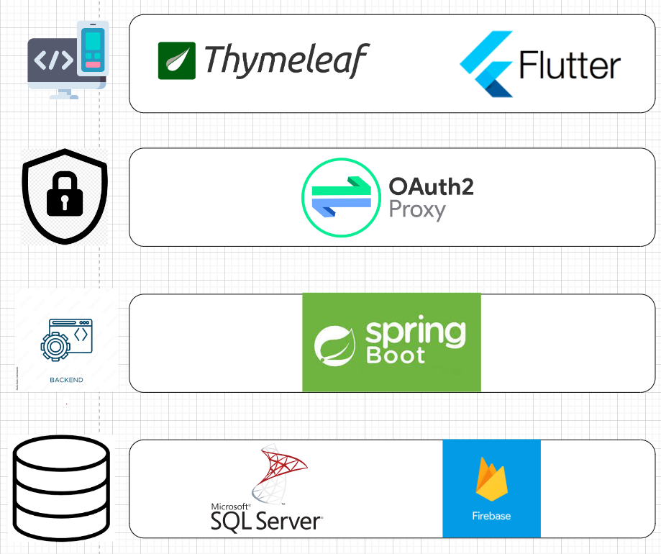

# **2. Use Case and Sequence Diagram**

## 2.1 Login

|  |  |  |  |
| --- | --- | --- | --- |
| ID and Name: | UC101 - Login | | |
| Primary Actor: | Unauthorized user | Secondary Actor: | n/a |
| Description: | Anonymous user login into the system, and give access to specific features according to his/her role | | |
| Pre-condition: | Anonymous user | | |
| Post-condition: | **Success**: claim access token and will be redirected to home Unauthorized userpage  **Fail**: the system show error message | | |
| Normal Flow: | **Web application:**   1. Anonymous user try to access restricted resource 2. He/she will be redirected to Login Page 3. User fill in the login form:    * Email: text input    * Password: password input 4. User clicks on “Login” button 5. OAuth2 authorization server validates given credentials and response access token 6. The browser immediately redirects the user to Home Page 7. Home Page shows up specific features based on the user’s role   **Mobile application:**   1. Anonymous user opens Pulse mobile application 2. Login Screen will show up 3. User fill in the login form:    * Email: text input    * Password: password input 4. User clicks on “Login” button 5. OAuth2 authorization server validates given credentials and response access token 6. Mobile app redirects user to Home Screen | | |
| Alternative Flow: | *n/a* | | |
| Exception Flow: | **Anonymous user fails to fill in all the required fields**   * Frontend shows messages MSG08   **Anonymous user provides incorrect credentials**   * Frontend shows message MSG04.   **internet connection lost**   * Frontend forwards to Lost internet page. | | |
| Priority: | High | | |
| Frequency of Usage: | Sometimes | | |

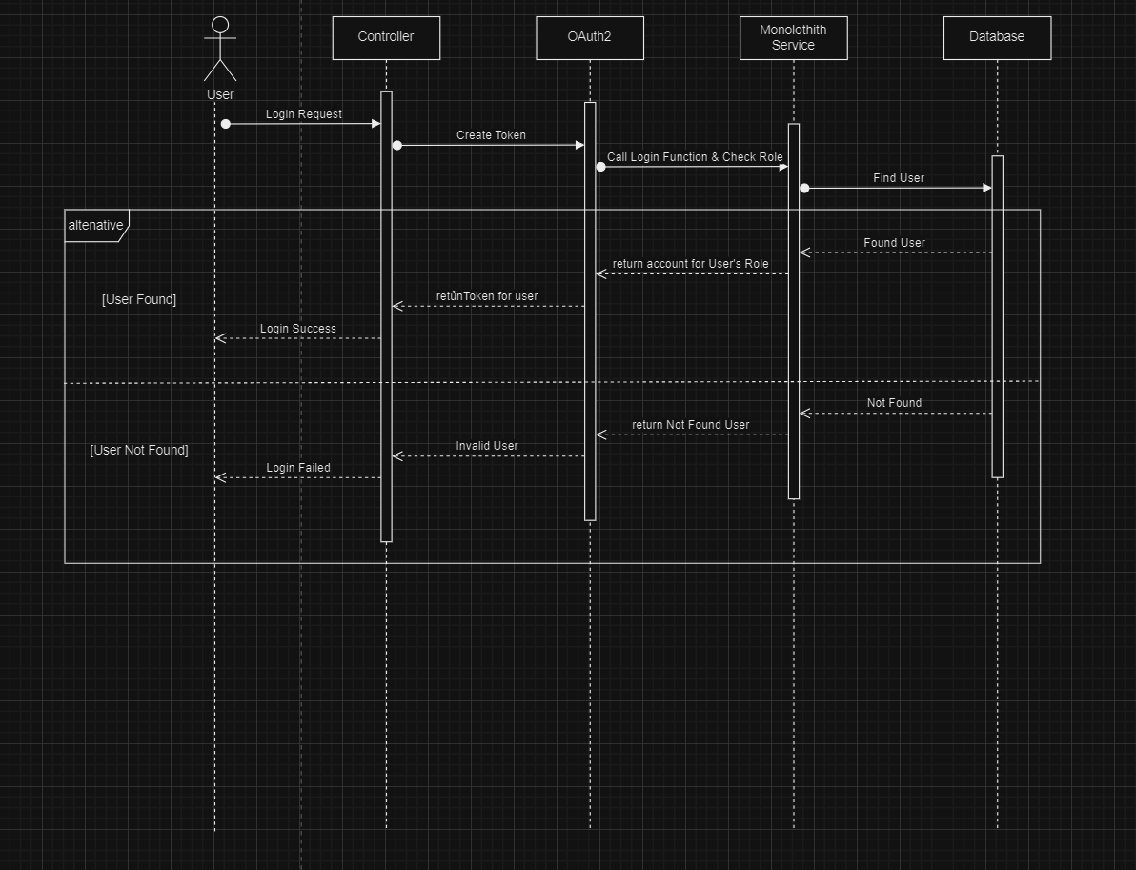

## 2.2 Logout

|  |  |  |  |
| --- | --- | --- | --- |
| ID and Name: | UC102 - Logout | | |
| Primary Actor: | Authenticated user | Secondary Actor: | n/a |
| Description: | User leaves the system and clears all access token in the browser. The system will require the user to log in again. | | |
| Pre-condition: | User successfully logged in | | |
| Post-condition: | User logged out, require to login again to access restricted resources | | |
| Normal Flow: | **Web application:**   1. User click on “Logout” button on the menu-bar 2. User will be redirect back to Login Page   **Mobile application:**   1. User taps on “Profile” icon at the bottom 2. Sidebar shows up 3. User taps on “Logout” button 4. User will be redirect back to Login Screen | | |
| Alternative Flow: | *n/a* | | |
| Exception Flow: | *n/a* | | |
| Priority: | High | | |
| Frequency of Usage: | sometimes | | |

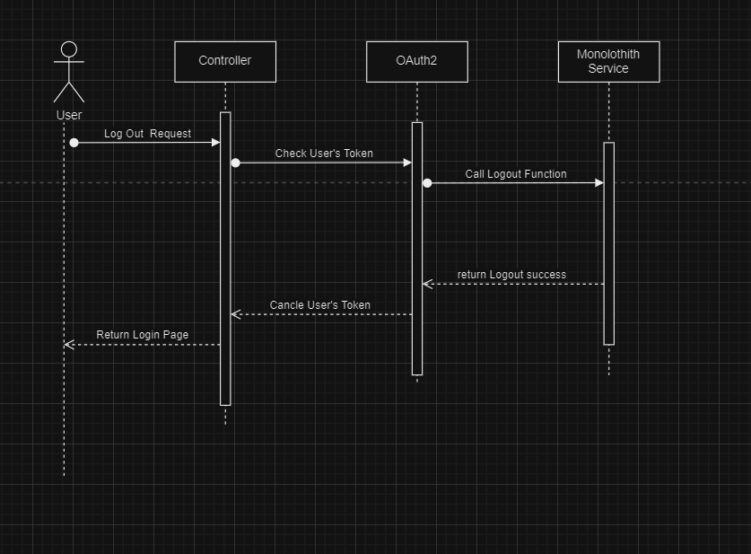

## 2.3 Change Password

|  |  |  |  |
| --- | --- | --- | --- |
| ID and Name: | UC103 - Change Password | | |
| Primary Actor: | Authenticated user | Secondary Actor: | n/a |
| Description: | User retype the old password and provide a new password for future authentication. | | |
| Pre-condition: | User successfully logged in | | |
| Post-condition: | User must use the new password to log in | | |
| Normal Flow: | **Web & Mobile application:**   1. User goes to Profile Page/Screen 2. User clicks/taps on “Change Password” button 3. Change Password form will show up 4. User fills in the form:    * New password: password input    * Confirm password: password input 5. User clicks/taps on “Submit” button 6. Pulse system response with a success status code 7. User will be navigated back to Profile Page/Screen | | |
| Alternative Flow: | *n/a* | | |
| Exception Flow: | **User didn’t provide enough required information**   * Frontend shows messages MSG08   **User provides an invalid confirm password**   * Frontend shows message MSG07. | | |
| Priority: | Medium | | |
| Frequency of Usage: | sometimes | | |

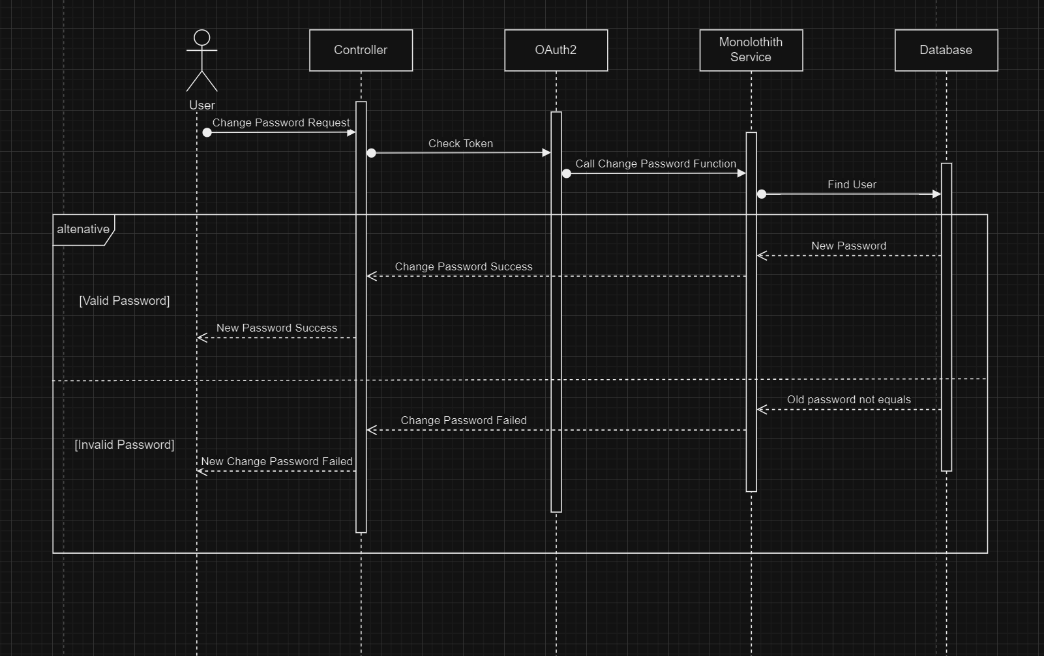

## 2.4 Forgot Password

|  |  |  |  |
| --- | --- | --- | --- |
| ID and Name: | UC104 - Forgot Password | | |
| Primary Actor: | Anonymous user | Secondary Actor: | n/a |
| Description: | Anonymous user request for reset password, and follow a reset password URL to provide new password | | |
| Pre-condition: | User is not logged in. User has an account it Pulse system. User is able to access the mailbox of the account’s email address. | | |
| Post-condition: | User must log in with the new password | | |
| Normal Flow: | **Web & Mobile application:**   1. Anonymous user goes to Login Page/Screen 2. He/she clicks/taps on “Forgot Password” link 3. Forgot Password Page shows up 4. User fills in the form:    * Email: input text 5. User clicks/taps on “Send Reset Password Mail” button 6. User receives a reset password mail in mailbox 7. User clicks/taps on the link 8. Reset Password Page shows up 9. User fills in the form:    * New password: password input    * Confirm password: password input 10. User clicks/tabs on “Submit” button 11. User will be redirected to Login Page/Screen | | |
| Alternative Flow: | *n/a* | | |
| Exception Flow: | **User didn’t provide enough required information**   * Frontend shows messages MSG08   **User provides invalid confirm password**   * Frontend shows message MSG07.   **User clicks on expired reset password URL**   * Frontend shows message MSG05. | | |
| Priority: | Medium | | |
| Frequency of Usage: | sometimes | | |

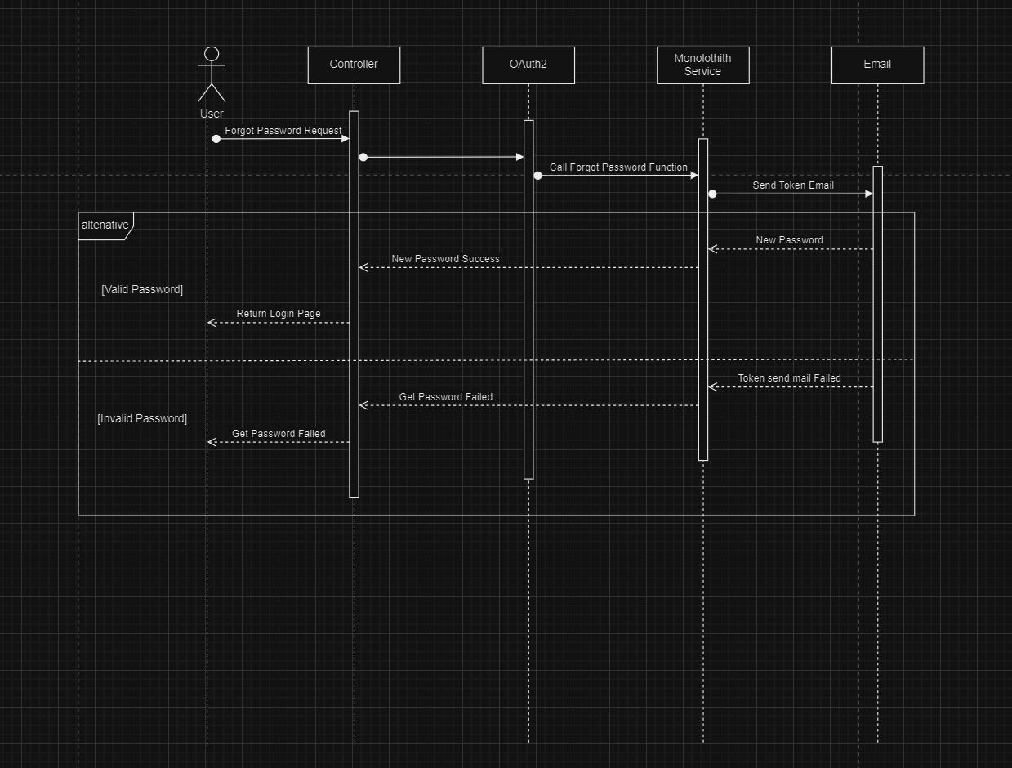

## 2.5 Sign Up

|  |  |  |  |
| --- | --- | --- | --- |
| ID and Name: | UC111 - Sign Up | | |
| Primary Actor: | Anonymous user | Secondary Actor: | n/a |
| Description: | Anonymous user register new account | | |
| Pre-condition: | User is not logged in. User has an account it Pulse system. User is able to access the mailbox of the account’s email address. | | |
| Post-condition: | User is able to login into Pulse mobile app | | |
| Normal Flow: | **Mobile application:**   1. Anonymous user opens Pulse mobile application 2. Login Screen will show up 3. User tap on “Sign Up” button 4. User fill in the registration form:    * Email: text input    * Password: password input    * Confirm Password: password input 5. User clicks on “Submit” button 6. Auth0 authorization server validates given credentials and send welcome email 7. Mobile app redirects user to Login Screen | | |
| Alternative Flow: | n/a | | |
| Exception Flow: | **User didn’t provide enough required information**   * Frontend shows messages MSG08   **User provides invalid information**   * Frontend shows message MSG07. | | |
| Priority: | Medium | | |
| Frequency of Usage: | Sometime | | |

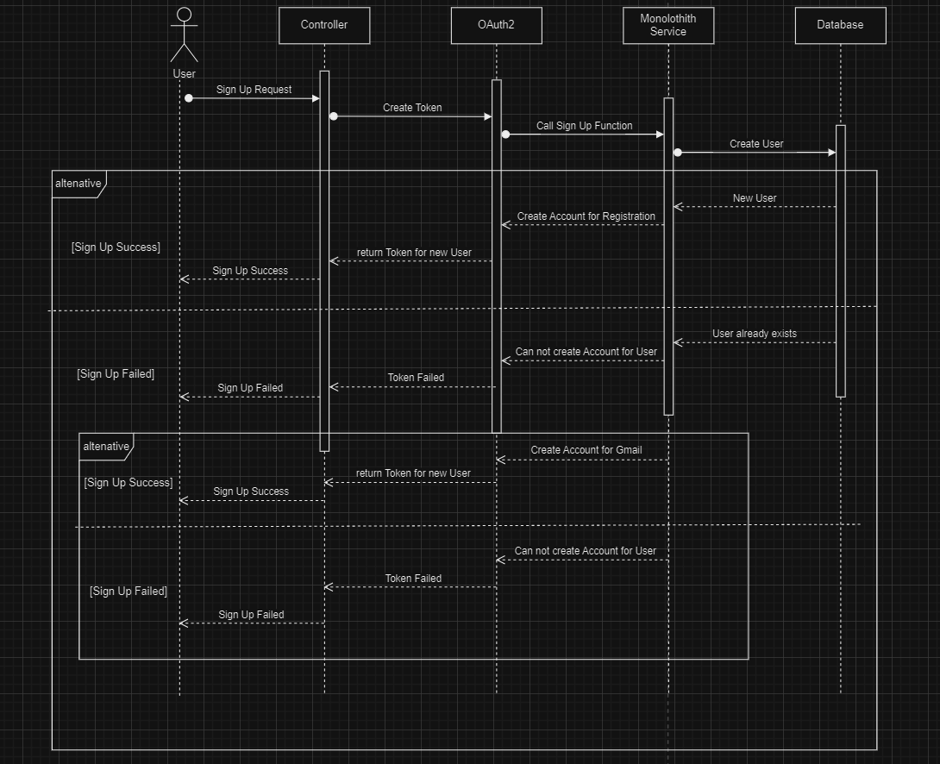

## 2.6 View Profile

|  |  |  |  |
| --- | --- | --- | --- |
| ID and Name: | UC107 - View Profile | | |
| Primary Actor: | Authenticated User | Secondary Actor: | n/a |
| Description: | Patient (or normal user) view his/her basic information on mobile app | | |
| Pre-condition: | User successfully logged in | | |
| Post-condition: | Detail personal information will be displayed | | |
| Normal Flow: | **Mobile application:**   1. User tap on “Profile” button on bottom right 2. Tap on the fullname 3. Display current personal information | | |
| Alternative Flow: | *n/a* | | |
| Exception Flow: | *n/a* | | |
| Priority: | Medium | | |
| Frequency of Usage: | Sometimes | | |

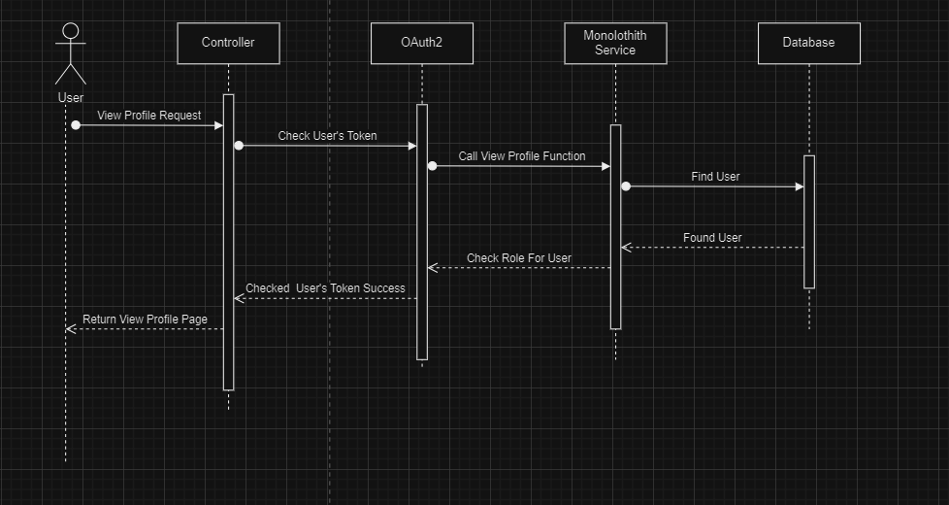

## 2.7 Edit Profile

|  |  |  |  |
| --- | --- | --- | --- |
| ID and Name: | UC108 - Edit Profile | | |
| Primary Actor: | Authenticated users | Secondary Actor: | n/a |
| Description: | User change some personal information | | |
| Pre-condition: | User successfully logged in | | |
| Post-condition: | Old information had been replaced by new information | | |
| Normal Flow: | **Web & Mobile application:**   1. User go to Profile Page 2. Current information will show up 3. User clicks/tabs on “Edit” button 4. Input fields will show up 5. User fill in new value:    * FirstName: input text    * MiddleName: input text    * LastName: input text    * Phone: input text    * Address: input text    * Nationality: input text    * Residential Status: citizen/foreigner    * Emergency Contact: input text 6. User clicks/tabs on “Save” button 7. Safari system response with a success status code 8. Profile Page display updated information | | |
| Alternative Flow: | *n/a* | | |
| Exception Flow: | **User fails to fill in all the required fields**   * Frontend shows messages MSG08   User provide invalid information (e.g. invalid format)   * Fronend shows message MSG07 | | |
| Priority: | High | | |
| Frequency of Usage: | Sometimes | | |

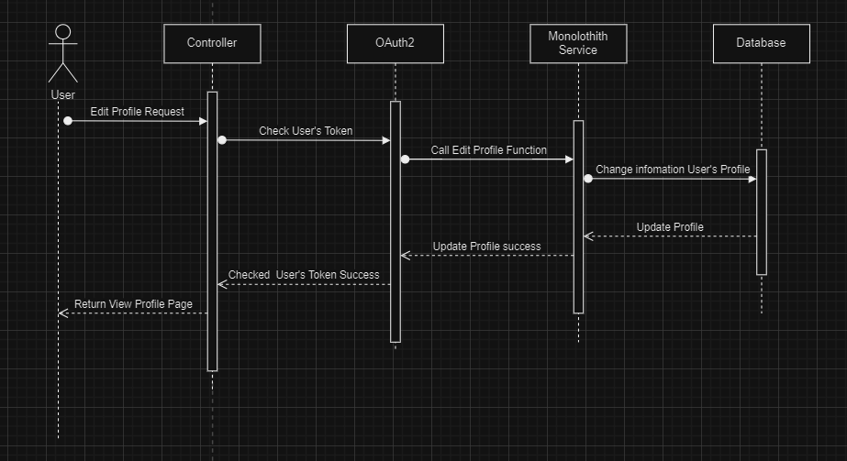

## 2.10 View / Search Staffs

|  |  |  |  |
| --- | --- | --- | --- |
| ID and Name: | UC201 - View / Search Staffs | | |
| Primary Actor: | Authenticated User | Secondary Actor: | n/a |
| Description: | Administrator (or high-level user) looking for staffs on dashboard.  Patient (or normal user) looking for staffs to complete booking appointment | | |
| Pre-condition: | User successfully logged in | | |
| Post-condition: | Nothing changed (user still logged in) | | |
| Normal Flow: | **Web application:**   1. User click on “Staff” module on sidebar 2. User sees a list of active staffs (by default) 3. User interact with inputs    * SearchText : input text    * Role : dropdown list 4. Pulse system filter by given criteria and response with a list of staffs   **Mobile application:**   1. User taps on “Booking” button 2. User choose type of appointment (teleconsultant or clinic visit) 3. User tap on “Appointed Clinician” to start select preferred clinician 4. User interact with inputs    * SearchText : input text 5. Pulse system filter by given criteria and response with a list of staffs | | |
| Alternative Flow: | *n/a* | | |
| Exception Flow: | **internet connection lost**   * Frontend forwards to Lost internet page. | | |
| Priority: | High | | |
| Frequency of Usage: | Often | | |

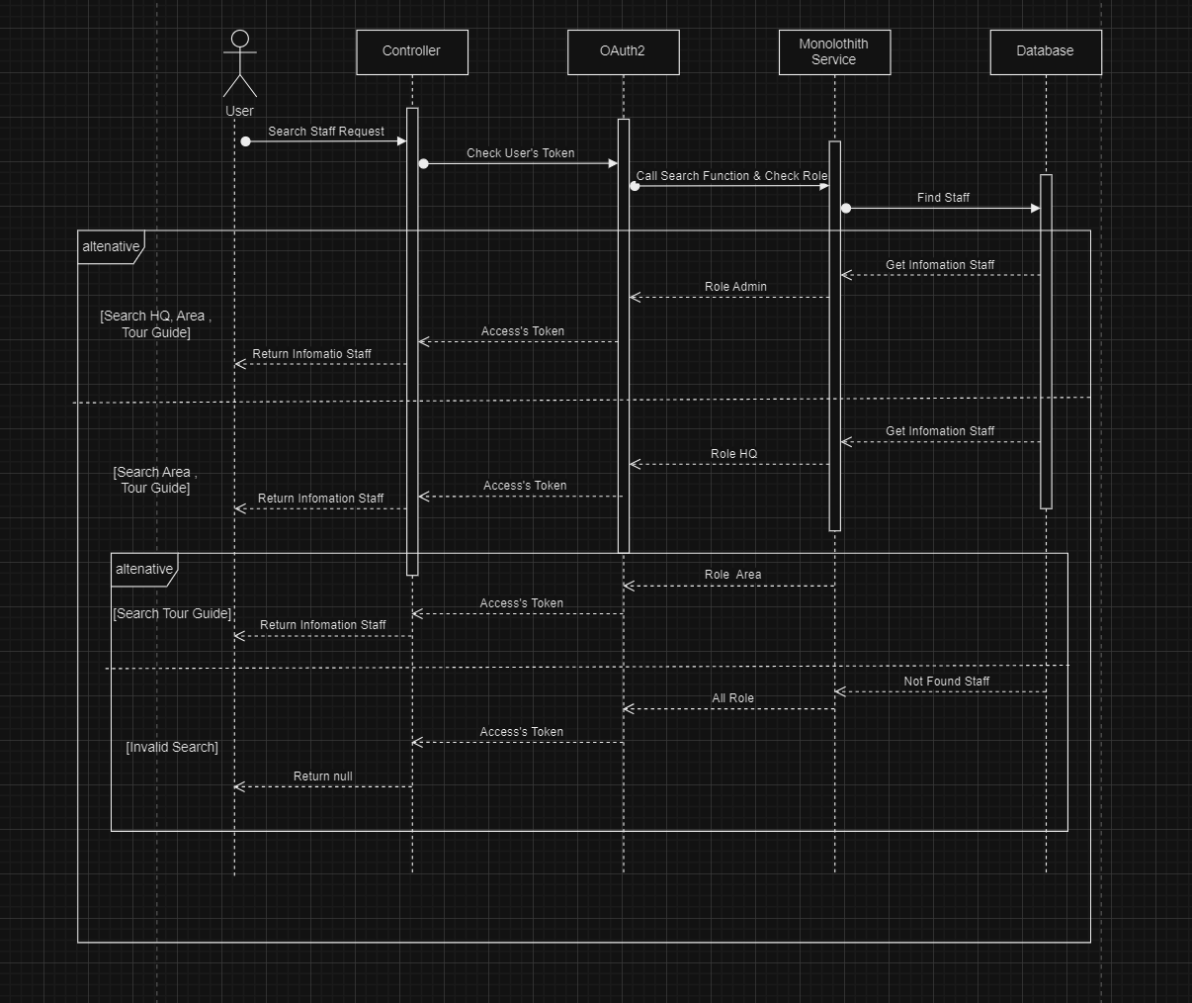

## 2.11 Add Staff

|  |  |  |  |
| --- | --- | --- | --- |
| ID and Name: | UC203 - Add Staff | | |
| Primary Actor: | Administrator | Secondary Actor: | n/a |
| Description: | Admin create new staff | | |
| Pre-condition: | Authenticated user with role Admin | | |
| Post-condition: | **Success:** New staff can request for reset password, then login and start to use Safari system  **Fail:** UI popup an error message | | |
| Normal Flow: | **Web & Mobile application:**   1. Admin clicks/taps “Staff” tab into right sidebar 2. Staff Page shows up 3. Admin clicks/taps “Create” button. 4. UI will show a dialog with blank fields:    1. Photo: File-picker (png, jpg, jpeg)    2. Email: input-text    3. First Name: input-text    4. Middle Name: input-text    5. Last Name: input-text    6. Gender: radio-button    7. Phone Number: input-number    8. Address: input-text    9. Schedule List: form-group       1. Date of Week: date-picker       2. From: time-picker       3. To: time-picker 5. Admin clicks/taps “Save” button. The browser make a request to create new Staff. 6. System create new staff and shows message MSG01. | | |
| Alternative Flow: | **Web & Mobile application:**   1. Admin clicks/taps on “Cancel” button. 2. UI shows confirm dialog. 3. Admin clicks/taps on “Cancel” button to closes a dialog and back to Staff Page | | |
| Exception Flow: | **Admin didn’t provide enough required information**   * Frontend shows messages MSG08   **Admin provides invalid information (e.g. invalid format)**   * Frontend shows message MSG07. | | |
| Priority: | High | | |
| Frequency of Usage: | sometimes | | |

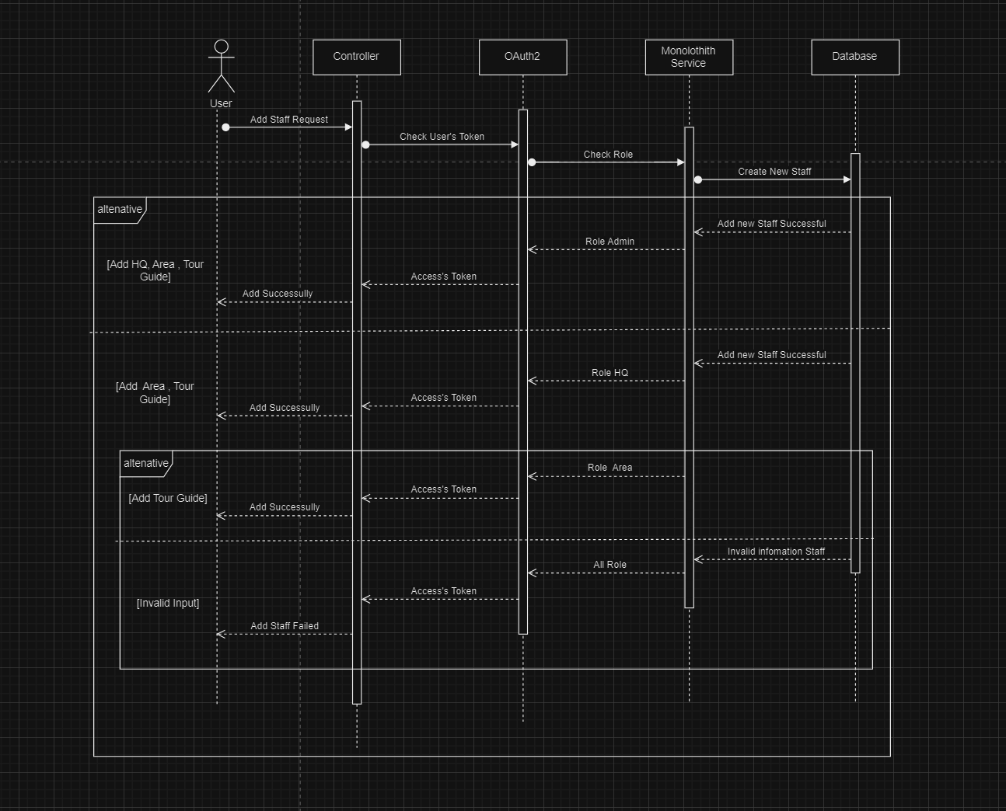

## 2.13 List/ Search User

|  |  |  |  |
| --- | --- | --- | --- |
| ID and Name: | UC601 - List / Search User | | |
| Primary Actor: | Authenticated user | Secondary Actor: | n/a |
| Description: | Admin/Staff views a list of Appointment, which are managed by Pulse. Admin/Staff is able to search, filter, sort the data | | |
| Pre-condition: | Authenticated user with role Admin and Staff | | |
| Post-condition: | **Success**: UI shows a list of Appointment.  **Fail**: UI popup an error message (e.g. access denied). | | |
| Normal Flow: | **Web & Mobile application:**   1. User clicks/taps “Appointment” tab into right sidebar 2. The patient page shows up, and the browser requests to get the patient list.    * User can filter by last name, first name, or appointment number in search bar on top right    * User can click on a column to get a sorted list by this information 3. This page contains a table, information include:    * Photo: image    * Name: text    * Age: number    * Contact: text    * Last appointment: text    * Sex: text    * Citizen: text    * Register Date: text 4. User can click/tap on a row to see detail information (a row will expand) | | |
| Alternative Flow: | *n/a* | | |
| Exception Flow: | **internet connection lost**   * Frontend forwards to Lost internet page. | | |
| Priority: | High | | |
| Frequency of Usage: | Often | | |

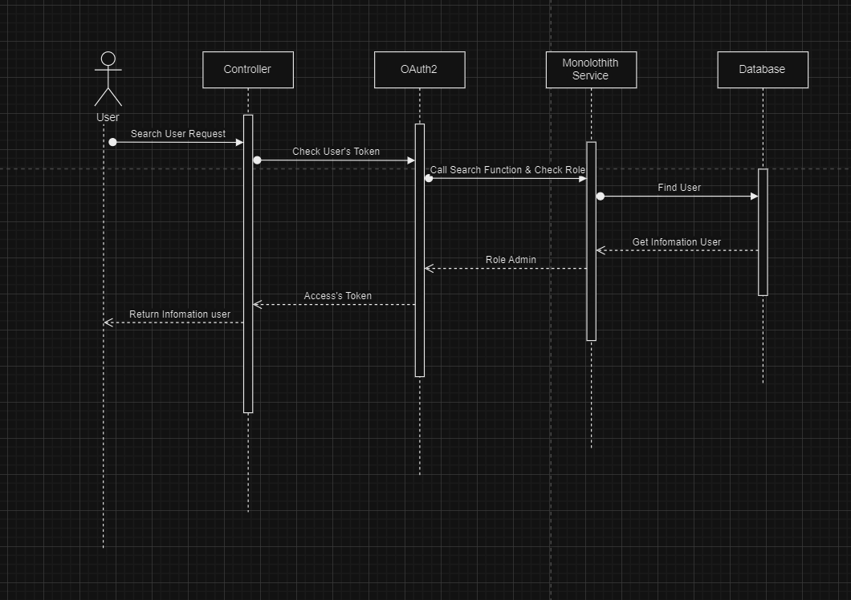

## 2.18 Add Tour

|  |  |  |  |
| --- | --- | --- | --- |
| ID and Name: | UC501 - Add Tour | | |
| Primary Actor: | Authenticated User | Secondary Actor: | n/a |
| Description: | Admin or Staff add new event at specific Outlet (Clinic) | | |
| Pre-condition: | Authenticated user with role Admin and Staff | | |
| Post-condition: | New schedule added | | |
| Normal Flow: | **Web application:**   1. User clicks “Schedule” tab into right sidebar 2. The schedule page shows up.    * User can filter by Outlet (Clinic) or by specific Staff    * User can switch between List View and Calendar View 3. User click on “Create Schedule” button 4. There is a form with following inputs:    * Doctor: dropdown list    * Date: datePicker    * From: time    * To: time    * Outlet: dropdown list    * Period: specific date or repeat 5. User submit new schedule | | |
| Alternative Flow: | *n/a* | | |
| Exception Flow: | **Admin didn’t provide enough required information**   * Frontend shows messages MSG08   **Admin provides invalid information (e.g. invalid format)**   * Frontend shows message MSG07. | | |
| Priority: | High | | |
| Frequency of Usage: | Often | | |

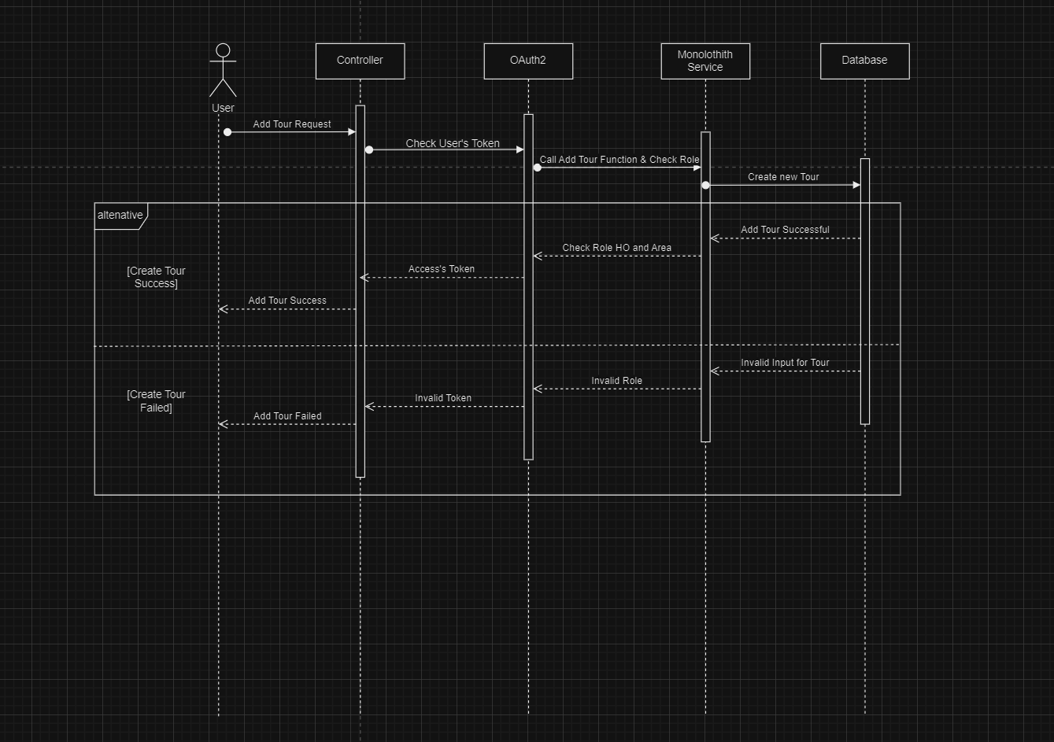

## 2.19 Edit Tour

|  |  |  |  |
| --- | --- | --- | --- |
| ID and Name: | UC502 - Edit Tour | | |
| Primary Actor: | Authenticated User | Secondary Actor: | n/a |
| Description: | Admin or Staff edit existing event at specific Outlet (Clinic) | | |
| Pre-condition: | Authenticated user with role Admin and Staff | | |
| Post-condition: | New time applied to existing schedule | | |
| Normal Flow: | **Web application:**   1. User clicks “Schedule” tab into right sidebar 2. The schedule page shows up.    * User can filter by Outlet (Clinic) or by specific Staff    * User can switch between List View and Calendar View 3. User can click on an event to see detail information 4. There is a form with following inputs:    * Date: datePicker    * From: time    * To: time    * Outlet: dropdown list 5. User submit the changes | | |
| Alternative Flow: | *n/a* | | |
| Exception Flow: | **Admin didn’t provide enough required information**   * Frontend shows messages MSG08   **Admin provides invalid information (e.g. invalid format)**   * Frontend shows message MSG07. | | |
| Priority: | High | | |
| Frequency of Usage: | Sometimes | | |

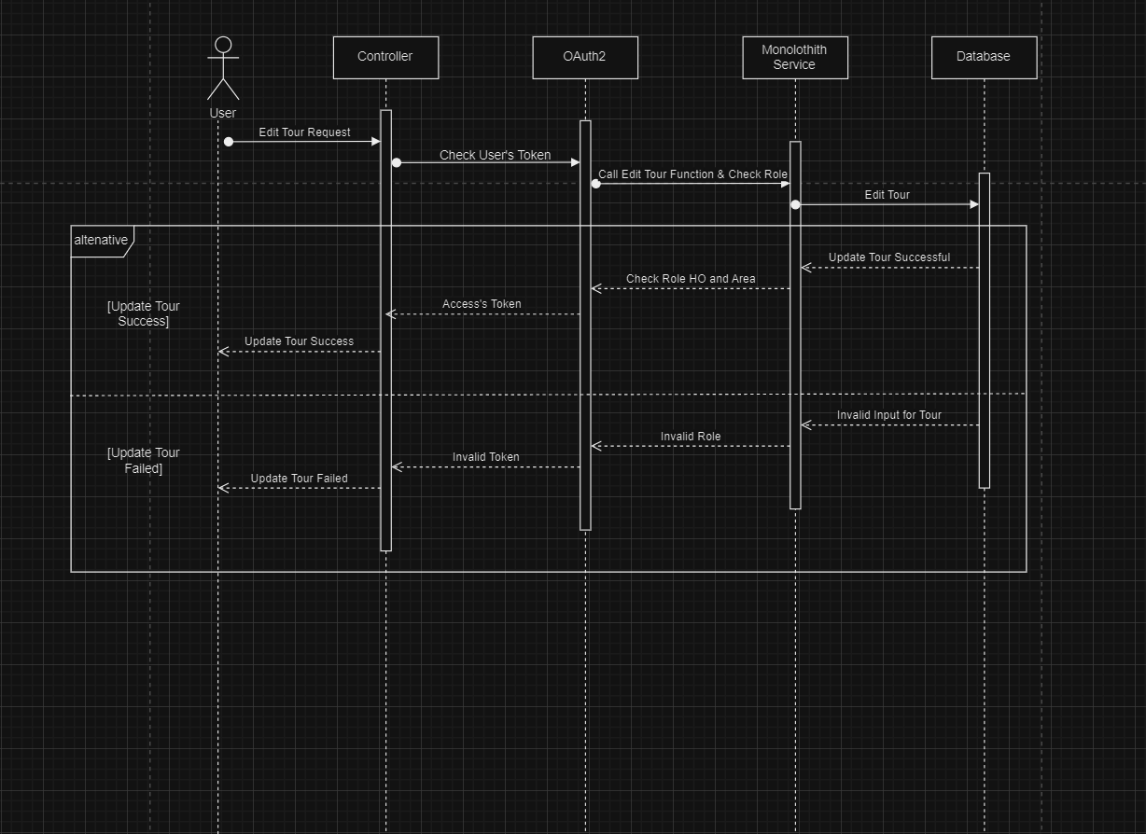

# **4. Table Definition**

## 4.1 Booking

|  |  |  |  |  |  |  |
| --- | --- | --- | --- | --- | --- | --- |
| **Key** | **Field Name** | **Data Type** | **Allow Null** | **Default Value** | **Reference Table** | **Description** |
| PK | Id | int | Yes | - | - |  |
| FK | schedule_id | int | No | - | - | Get Schedule |
| FK | user_id | int | No | - | - | Get user |
|  | adult | int | No | - | - | Quantity |
|  | baby | int | No | - | - | Quantity |
|  | senior | int | No | - | - | Quantity |
|  | children | int | No | - | - | Quantity |
|  | booking_date | datetime | No | CURDATE() + 1 | - |  |
| FK | region_id | int | No | - | - | Get Region |

**Constraints:**

|  |  |  |
| --- | --- | --- |
| **Name** | **Field Name** | **Type** |
| scheduleId | schedule_id | Unique, Non-Clustered |
| userId | user_id | Unique, Non-Clustered |
| regionId | region_id | Unique, Non-Clustered |

## 4.2 Chat Message

|  |  |  |  |  |  |  |
| --- | --- | --- | --- | --- | --- | --- |
| **Key** | **Field Name** | **Data Type** | **Allow Null** | **Default Value** | **Reference Table** | **Description** |
| PK | id | int | Yes | - | - |  |
|  | content | ntext | No | - | - |  |
| FK | usergroup_id | int | No | - | - | Get user group |

**Constraints:**

|  |  |  |
| --- | --- | --- |
| **Name** | **Field Name** | **Type** |
| usergroupId | usergroup_id | Unique, Non-Clustered |

## 4.3 Comment Post

|  |  |  |  |  |  |  |
| --- | --- | --- | --- | --- | --- | --- |
| **Key** | **Field Name** | **Data Type** | **Allow Null** | **Default Value** | **Reference Table** | **Description** |
| PK | id | int | Yes | - | - |  |
| FK | user_id | int | No | - | - | Get User |
| FK | post_id | int | No | - | - | Get Post |
|  | comment_date | datetime | No | - | - |  |
|  | content | int | No | - | - |  |
| FK | parent_id | int | No | - | - | Get Parent |

**Constraints:**

|  |  |  |
| --- | --- | --- |
| **Name** | **Field Name** | **Type** |
| postId | post_id | Unique, Non-Clustered |
| userId | user_id | Unique, Non-Clustered |
| parentId | parent_id | Unique, Non-Clustered |

## 4.4 Company

|  |  |  |  |  |  |  |
| --- | --- | --- | --- | --- | --- | --- |
| **Key** | **Field Name** | **Data Type** | **Allow Null** | **Default Value** | **Reference Table** | **Description** |
| PK | id | int | Yes | - | - |  |
|  | name | varchar(255) | No | - | - |  |
|  | logo | varchar(255) | No | - | - |  |
|  | status | bit | No | - | - |  |
|  | address | varchar(255) | No | - | - |  |
|  | total_revenue | decimal(15, 2) | No | - | - |  |
|  | term_of_service | ntext | No | - | - |  |
|  | hotline | int | No | - | - |  |
|  | email | varchar(100) | No | - | - |  |

## 4.5 Coupon

|  |  |  |  |  |  |  |
| --- | --- | --- | --- | --- | --- | --- |
| **Key** | **Field Name** | **Data Type** | **Allow Null** | **Default Value** | **Reference Table** | **Description** |
| PK | id | int | Yes | - | - |  |
|  | code | varchar(255) | No | - | - |  |
|  | discount | decimal(15, 2) | No | - | - |  |
|  | expiration_date | datetime | No | - | - |  |
| FK | user_id | int | No | - | - | Get User |

**Constraints:**

|  |  |  |
| --- | --- | --- |
| **Name** | **Field Name** | **Type** |
| userId | user_id | Unique, Non-Clustered |

## 4.6 Favorite

|  |  |  |  |  |  |  |
| --- | --- | --- | --- | --- | --- | --- |
| **Key** | **Field Name** | **Data Type** | **Allow Null** | **Default Value** | **Reference Table** | **Description** |
| PK | id | int | Yes | - | - |  |
| FK | user_id | int | No | - | - | Get User |
| FK | tour_id | int | No | - | - | Get Tour |

**Constraints:**

|  |  |  |
| --- | --- | --- |
| **Name** | **Field Name** | **Type** |
| userId | user_id | Unique, Non-Clustered |
| tourId | tour_id | Unique, Non-Clustered |

## 4.7 Favorite Post

|  |  |  |  |  |  |  |
| --- | --- | --- | --- | --- | --- | --- |
| **Key** | **Field Name** | **Data Type** | **Allow Null** | **Default Value** | **Reference Table** | **Description** |
| PK | id | int | Yes | - | - |  |
| FK | user_id | int | No | - | - | Get User |
| FK | post_id | int | No | - | - | Get Post |

**Constraints:**

|  |  |  |
| --- | --- | --- |
| **Name** | **Field Name** | **Type** |
| userId | user_id | Unique, Non-Clustered |
| postId | post_id | Unique, Non-Clustered |

## 4.8 Friend

|  |  |  |  |  |  |  |
| --- | --- | --- | --- | --- | --- | --- |
| **Key** | **Field Name** | **Data Type** | **Allow Null** | **Default Value** | **Reference Table** | **Description** |
| PK | id | int | Yes | - | - |  |
| FK | user_id | int | No | - | - | Get User |
| FK | Friend_id | int | No | - | - | Get Friend |
|  | status | bit | No | - | - |  |

**Constraints:**

|  |  |  |
| --- | --- | --- |
| **Name** | **Field Name** | **Type** |
| userId | user_id | Unique, Non-Clustered |
| friendtId | friend_id | Unique, Non-Clustered |

## 4.9 Group Chat

|  |  |  |  |  |  |  |
| --- | --- | --- | --- | --- | --- | --- |
| **Key** | **Field Name** | **Data Type** | **Allow Null** | **Default Value** | **Reference Table** | **Description** |
| PK | id | int | Yes | - | - |  |
|  | name | varchar(100) | No | - | - |  |
|  | Member_account | int | No | - | - |  |

## 4.10 Hotels

|  |  |  |  |  |  |  |
| --- | --- | --- | --- | --- | --- | --- |
| **Key** | **Field Name** | **Data Type** | **Allow Null** | **Default Value** | **Reference Table** | **Description** |
| PK | id | int | Yes | - | - |  |
| FK | region_id | int | No | - | - | Get Region |
|  | hotel_name | varchar(255) | No | - | - |  |

**Constraints:**

|  |  |  |
| --- | --- | --- |
| **Name** | **Field Name** | **Type** |
| regionId | region_id | Unique, Non-Clustered |

## 4.11 Information Booking

|  |  |  |  |  |  |  |
| --- | --- | --- | --- | --- | --- | --- |
| **Key** | **Field Name** | **Data Type** | **Allow Null** | **Default Value** | **Reference Table** | **Description** |
| PK | id | int | Yes | - | - |  |
| FK | name | varchar(200) | No | - | - |  |
|  | phone | varchar(15) | No | - | - |  |
|  | email | varchar(150) | No | - | - |  |
|  | address | varchar(300) | No | - | - |  |
|  | gender | bit | No | - | - |  |
|  | cccd | varchar(50) | No | - | - |  |
|  | booking_id | int | No | - | - | Get Booking |

**Constraints:**

|  |  |  |
| --- | --- | --- |
| **Name** | **Field Name** | **Type** |
| regionId | region_id | Unique, Non-Clustered |

## 4.12 Invite

|  |  |  |  |  |  |  |
| --- | --- | --- | --- | --- | --- | --- |
| **Key** | **Field Name** | **Data Type** | **Allow Null** | **Default Value** | **Reference Table** | **Description** |
| PK | id | int | Yes | - | - |  |
| FK | sender_id | int | No | - | - | Get Sender |
| FK | recipient_id | int | No | - | - | Get Recipient |
|  | status | bit | No | - | - |  |

**Constraints:**

|  |  |  |
| --- | --- | --- |
| **Name** | **Field Name** | **Type** |
| senderId | sender_id | Unique, Non-Clustered |
| recipientId | recipient_id | Unique, Non-Clustered |

## 4.13 Item

|  |  |  |  |  |  |  |
| --- | --- | --- | --- | --- | --- | --- |
| **Key** | **Field Name** | **Data Type** | **Allow Null** | **Default Value** | **Reference Table** | **Description** |
| PK | id | int | Yes | - | - |  |
|  | name | varchar(100) | No | - | - |  |
|  | quantity | int | No | - | - |  |

## 4.14 News

|  |  |  |  |  |  |  |
| --- | --- | --- | --- | --- | --- | --- |
| **Key** | **Field Name** | **Data Type** | **Allow Null** | **Default Value** | **Reference Table** | **Description** |
| PK | id | int | Yes | - | - |  |
|  | title | varchar(255) | No | - | - |  |
|  | context | ntext | No | - | - |  |
|  | start_date | datetime | No | - | - |  |
| FK | user_id | int | No | - | User | Get User |
|  | image | longtext | No | - | - |  |

**Constraints:**

|  |  |  |
| --- | --- | --- |
| **Name** | **Field Name** | **Type** |
| userId | user_id | Unique, Non-Clustered |

## 4.15 Payment

|  |  |  |  |  |  |  |
| --- | --- | --- | --- | --- | --- | --- |
| **Key** | **Field Name** | **Data Type** | **Allow Null** | **Default Value** | **Reference Table** | **Description** |
| PK | id | int | Yes | - | - |  |
|  | price | Decimal(15,2) | No | - | - |  |
|  | date | datetime | No | CURDATE() + 1 | - |  |
|  | status | Tinyint | No | - | - |  |
|  | description | varchar(255) | No | - | - |  |
| FK | user_id | int | No | - | User | Get User |
| FK | booking_id | int | No | - | Booking | Get Booking |
|  | payment_method | bit | No | - | - |  |

**Constraints:**

|  |  |  |
| --- | --- | --- |
| **Name** | **Field Name** | **Type** |
| userId | user_id | Unique, Non-Clustered |
| bookingId | booking_id | Unique, Non-Clustered |

## 4.16 Post

|  |  |  |  |  |  |  |
| --- | --- | --- | --- | --- | --- | --- |
| **Key** | **Field Name** | **Data Type** | **Allow Null** | **Default Value** | **Reference Table** | **Description** |
| PK | id | int | Yes | - | - |  |
| FK | user_id | int | No | - | User | Get User |
|  | image | longtext | No | - | - |  |
|  | status | varchar(100) | No | - | - |  |
|  | post_date | datetime | No | - | - |  |
|  | hashtag | varchar(255) | No | - | - |  |

**Constraints:**

|  |  |  |
| --- | --- | --- |
| **Name** | **Field Name** | **Type** |
| userId | user_id | Unique, Non-Clustered |

## 4.17 Region

|  |  |  |  |  |  |  |
| --- | --- | --- | --- | --- | --- | --- |
| **Key** | **Field Name** | **Data Type** | **Allow Null** | **Default Value** | **Reference Table** | **Description** |
| PK | id | int | Yes | - | - |  |
|  | Name_area | varchar(50) | No | - | - |  |

## 

## 4.18 Review

|  |  |  |  |  |  |  |
| --- | --- | --- | --- | --- | --- | --- |
| **Key** | **Field Name** | **Data Type** | **Allow Null** | **Default Value** | **Reference Table** | **Description** |
| PK | id | int | Yes | - | - |  |
| FK | user_id | int | No | - | User | Get User |
| FK | tour_id | int | No | - | - |  |
|  | context | ntext | No | - | - |  |
|  | review_date | datetime | No | - | - |  |
|  | reply | ntext | No | - | - |  |
|  | reply_date | datetime | No | - | - |  |
|  | rate | Float | No | - | - |  |

**Constraints:**

|  |  |  |
| --- | --- | --- |
| **Name** | **Field Name** | **Type** |
| userId | user_id | Unique, Non-Clustered |
| tourId | tour_id | Unique, Non-Clustered |

## 4.19 Roles

|  |  |  |  |  |  |  |
| --- | --- | --- | --- | --- | --- | --- |
| **Key** | **Field Name** | **Data Type** | **Allow Null** | **Default Value** | **Reference Table** | **Description** |
| PK | id | int | Yes | - | - |  |
|  | name | varchar(50) | No | - | - |  |
|  | description | ntext | No | - | - |  |

## 4.20 Schedule

|  |  |  |  |  |  |  |
| --- | --- | --- | --- | --- | --- | --- |
| **Key** | **Field Name** | **Data Type** | **Allow Null** | **Default Value** | **Reference Table** | **Description** |
| PK | id | int | Yes | - | - |  |
| FK | tour_id | int | No | - | - | Get Tour |
|  | start_date | datetime | No | - | - |  |
|  | end_date | datetime | No | - | - |  |
|  | quantity_passenger | int | No | - | - |  |
|  | quantity_min | int | No | - | - |  |
|  | quantity_max | int | No | - | - |  |

**Constraints:**

|  |  |  |
| --- | --- | --- |
| **Name** | **Field Name** | **Type** |
| tourId | tour_id | Unique, Non-Clustered |

## 4.21 ScheduleImage

|  |  |  |  |  |  |  |
| --- | --- | --- | --- | --- | --- | --- |
| **Key** | **Field Name** | **Data Type** | **Allow Null** | **Default Value** | **Reference Table** | **Description** |
| PK | id | int | Yes | - | - |  |
| FK | schedule_item_id | int | No | - | ScheduleItem | Get ScheduleItem |
|  | image | longtext | No | - | - |  |
|  | Description | ntext | No | - | - |  |

**Constraints:**

|  |  |  |
| --- | --- | --- |
| **Name** | **Field Name** | **Type** |
| scheduleItemId | schedule_item_id | Unique, Non-Clustered |

## 4.22 ScheduleItem

|  |  |  |  |  |  |  |
| --- | --- | --- | --- | --- | --- | --- |
| **Key** | **Field Name** | **Data Type** | **Allow Null** | **Default Value** | **Reference Table** | **Description** |
| PK | id | int | Yes | - | - |  |
| FK | schedule_id | int | No | - | Schedule | Get Schedule |
|  | name_day | varchar(50) | No | - | - |  |
|  | title | varchar(200) | No | - | - |  |
|  | description | ntext | No | - | - |  |

**Constraints:**

|  |  |  |
| --- | --- | --- |
| **Name** | **Field Name** | **Type** |
| scheduleId | schedule_id | Unique, Non-Clustered |

## 4.23 ServiceImage

|  |  |  |  |  |  |  |
| --- | --- | --- | --- | --- | --- | --- |
| **Key** | **Field Name** | **Data Type** | **Allow Null** | **Default Value** | **Reference Table** | **Description** |
| PK | id | int | Yes | - | - |  |
| FK | schedule_id | int | No | - | Schedule | Get Schedule |
|  | title | varchar(200) | No | - | - |  |
|  | Description | ntext | No | - | - |  |

**Constraints:**

|  |  |  |
| --- | --- | --- |
| **Name** | **Field Name** | **Type** |
| scheduleId | schedule_id | Unique, Non-Clustered |

## 4.24 Slot

|  |  |  |  |  |  |  |
| --- | --- | --- | --- | --- | --- | --- |
| **Key** | **Field Name** | **Data Type** | **Allow Null** | **Default Value** | **Reference Table** | **Description** |
| PK | id | int | Yes | - | - |  |
| FK | tour_id | int | No | - | Tour | Get Tour |
|  | quantity | int | No | - | - |  |

**Constraints:**

|  |  |  |
| --- | --- | --- |
| **Name** | **Field Name** | **Type** |
| tourId | tour_id | Unique, Non-Clustered |

## 4.25 Tour

|  |  |  |  |  |  |  |
| --- | --- | --- | --- | --- | --- | --- |
| **Key** | **Field Name** | **Data Type** | **Allow Null** | **Default Value** | **Reference Table** | **Description** |
| PK | id | int | Yes | - | - |  |
| FK | guide_id | int | No | - | - | Get Guide |
|  | transpost_id | int | No | - | Transpost | Get Transpost |
|  | name | varchar(255) | No | - | - |  |
|  | description | ntext | No | - | - |  |
|  | price | Decimal(18,0) | No | - | - |  |
|  | discount | int | No | - | - |  |
|  | image | longtext | No | - | - |  |
|  | company_id | int | No | - | Company | Get Company |
|  | views | int | No | - | - |  |
|  | is_top_pick | bit | No | - | - |  |
|  | region_id | int | No | - | Region | Get Region |

**Constraints:**

|  |  |  |
| --- | --- | --- |
| **Name** | **Field Name** | **Type** |
| guideId | guide_id | Unique, Non-Clustered |
| transpostId | transpost_id | Unique, Non-Clustered |
| companyId | company_id | Unique, Non-Clustered |
| regionId | regionId | Unique, Non-Clustered |

## 4.26 Transpost

|  |  |  |  |  |  |  |
| --- | --- | --- | --- | --- | --- | --- |
| **Key** | **Field Name** | **Data Type** | **Allow Null** | **Default Value** | **Reference Table** | **Description** |
| PK | id | int | Yes | - | - |  |
|  | name | varchar(100) | No | - | - |  |

## 4.27 UserGroup

|  |  |  |  |  |  |  |
| --- | --- | --- | --- | --- | --- | --- |
| **Key** | **Field Name** | **Data Type** | **Allow Null** | **Default Value** | **Reference Table** | **Description** |
| PK | id | int | Yes | - | - |  |
|  | user_id | int | No | - | User | Get User |
|  | groupchat_id | int | No | - | GroupChat | Get GroupChat |

**Constraints:**

|  |  |  |
| --- | --- | --- |
| **Name** | **Field Name** | **Type** |
| userId | user_id | Unique, Non-Clustered |
| groupchatId | groupchat_id | Unique, Non-Clustered |

## 4.28 User

|  |  |  |  |  |  |  |
| --- | --- | --- | --- | --- | --- | --- |
| **Key** | **Field Name** | **Data Type** | **Allow Null** | **Default Value** | **Reference Table** | **Description** |
| PK | id | int | Yes | - | - |  |
| FK | company_id | int | No | - | Company | Get Company |
|  | first_name | Vachar(50) | No | - | - |  |
|  | last_name | varchar(50) | No | - | - |  |
|  | email | varchar(100) | No | - | - |  |
|  | password | varchar(255) | No | - | - |  |
|  | address | varchar(255) | No | - | - |  |
|  | phone | varchar(15) | No | - | - |  |
|  | avatar | longtext | No | - | - |  |
|  | verifycode | Char(4) | No | - | - |  |
|  | token | Nvarchar(Max) | No | - | - |  |
|  | total_invite | int | No | - | - |  |
|  | coin | int | No | - | - |  |
|  | role_id | int | No | - | Roles | Get Role |
|  | status | bit | No | - | - |  |

**Constraints:**

|  |  |  |
| --- | --- | --- |
| **Name** | **Field Name** | **Type** |
| companyId | company_id | Unique, Non-Clustered |
| roleId | role_id | Unique, Non-Clustered |

# **5. Relational Schema**

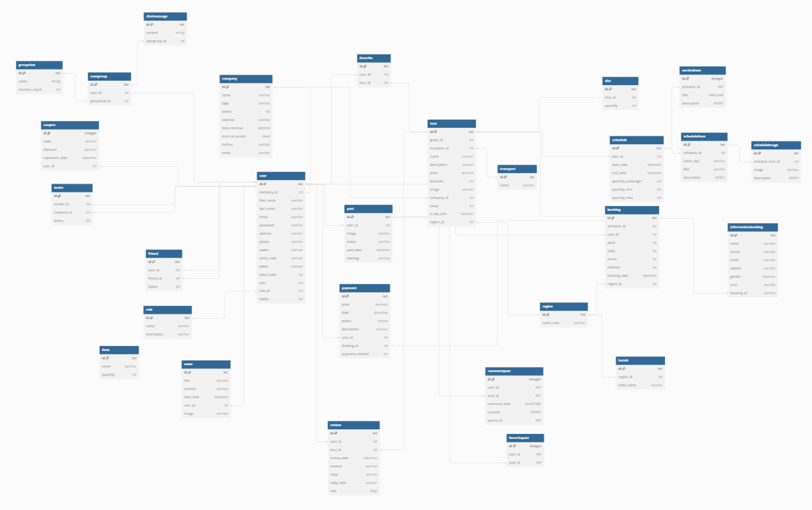

Task Sheet 2

|  |  |  |  |  |  |
| --- | --- | --- | --- | --- | --- |
| **Members Group** | | **Date Preparation of Activity Plan** | | | |
| **No** | **Name** | **Description Task** | **Start Date** | **End Date** | **Status** |
| 1 | Hoang Quoc Vinh  Nguyen Anh Phu | Architecture Design |  |  | completed |
| Use Case & Sequence Diagram |  |  | completed |
| Class Diagram |  |  | completed |
| Table Definition |  |  | completed |
| 2 | Tran Cong Thinh | Use Case & Sequence Diagram |  |  | completed |
| 3 | Huynh Ngoc Thai |  |  | completed |
| 4 | Nguyen Dinh Duc | Relational Schema |  |  | completed |
|  | | | | | |
| **Teacher** | | | **Team Leader** | | |
|  | | |  | | |
|  | | |  | | |

**REVIEW 3**

# **1. Web GUI Design**

## 1.1 Home :

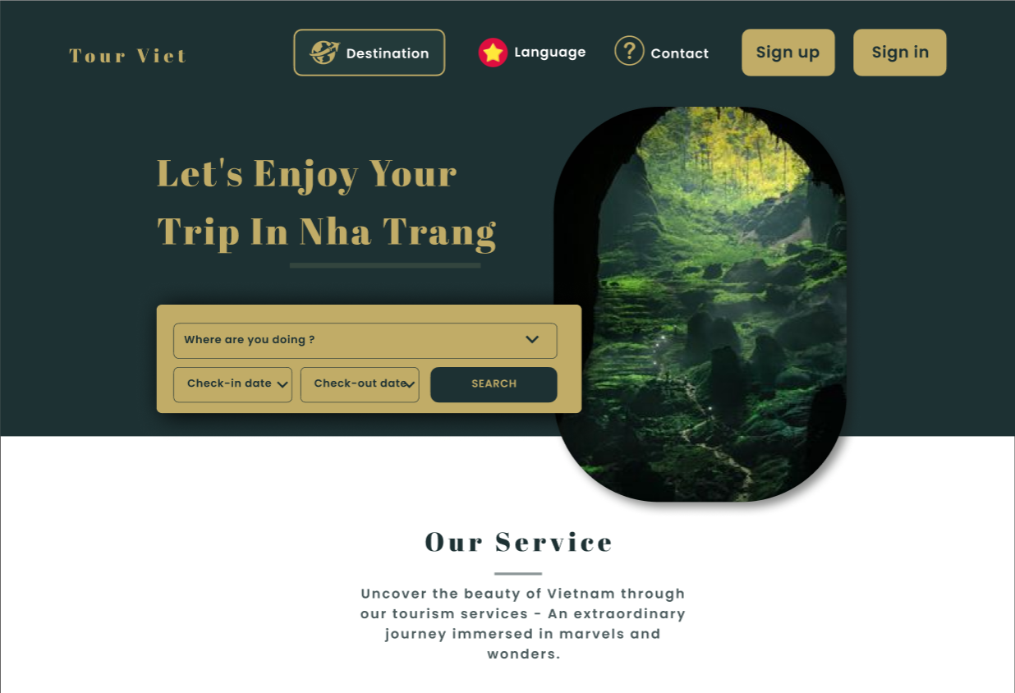

-Clicking Sign In will take you to the login page so you can use more web functions (IMAGE 1.6)

-If you do not have an account, you can click Sign Up to register an account or you can choose to sign in with your Gmail account (IMAGE 1.7)

-Click on the language to choose the language you want like Vietnamese or English (IMAGE1.9)

-Click on Destination to choose the place you want to travel (IMAGE 1.8)

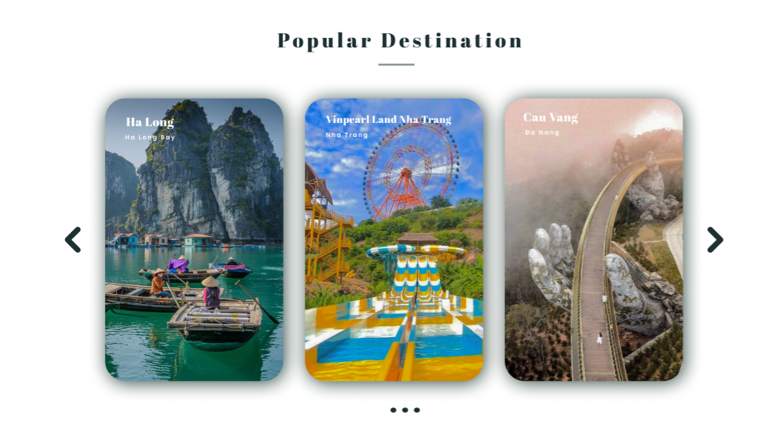

-You can see some famous tours in Vietnam in Popular Destination

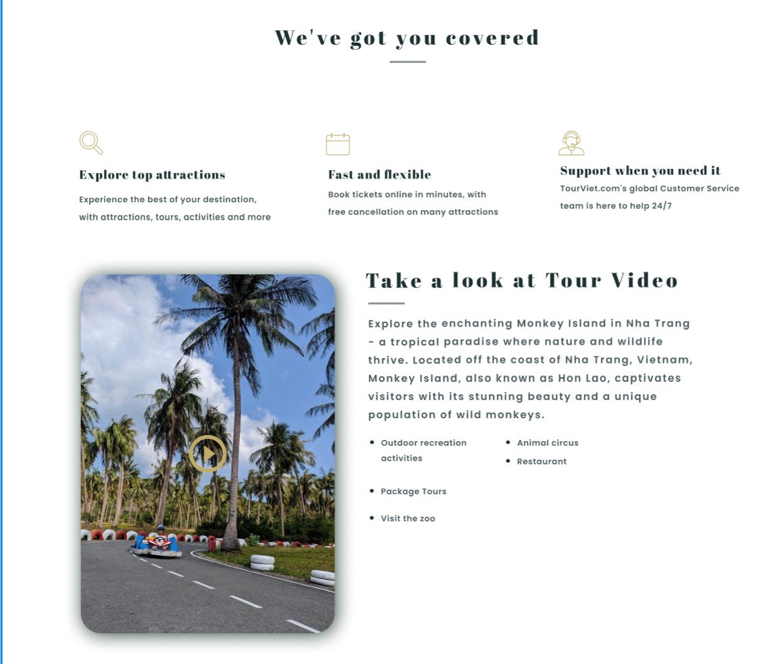

-At We've got you covered you can watch our video rewind

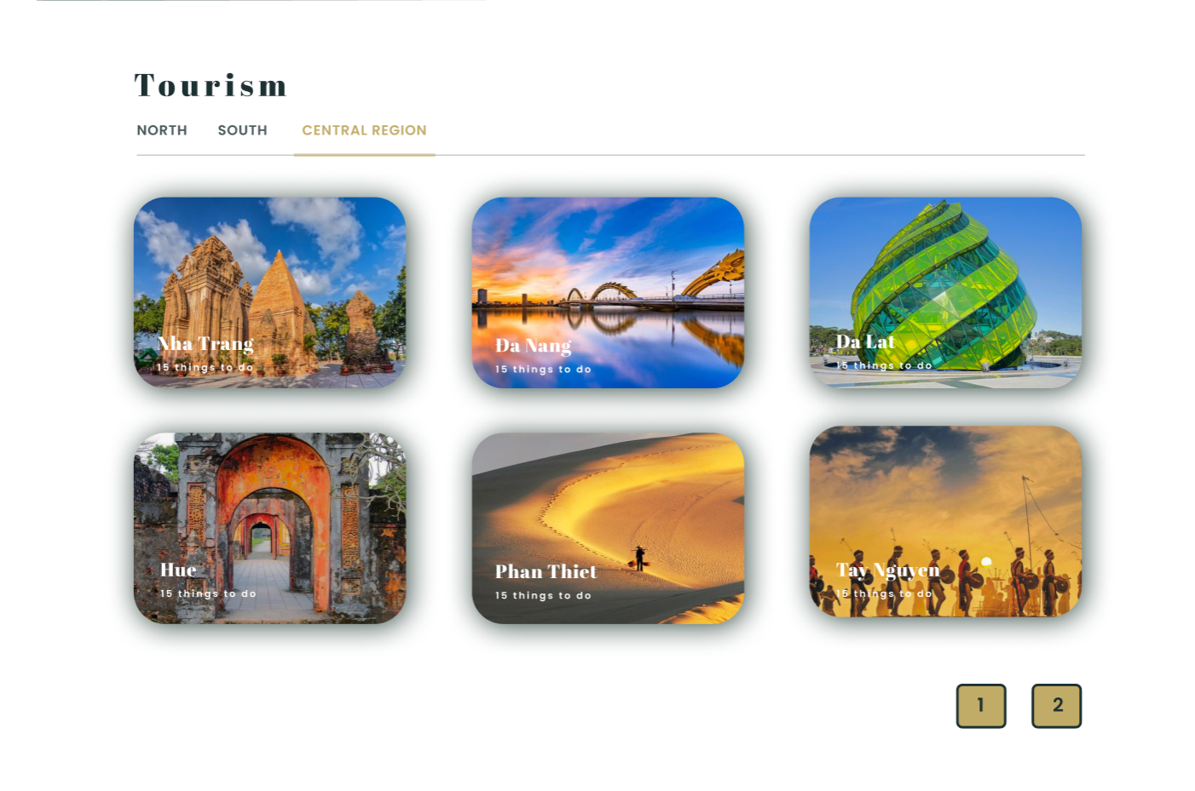

-At Tourism you can see famous tours in regions in Vietnam



-Click on Let's Explore to proceed with the tour

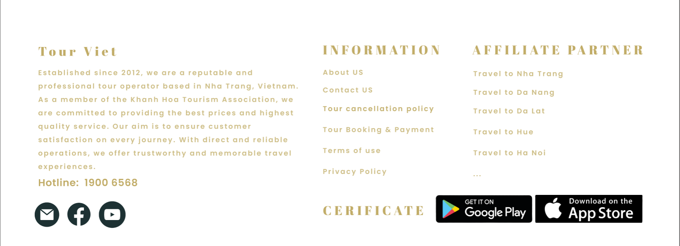

-In the Footer of the Web you can find more information as well as the terms of use of our website and our partners.

## 1.2 Details :

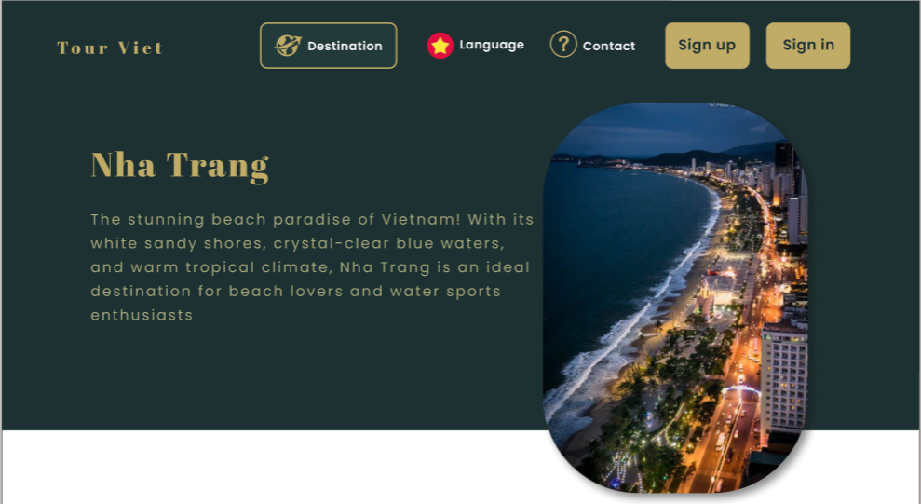

-When choosing any tour, we will briefly introduce that place here

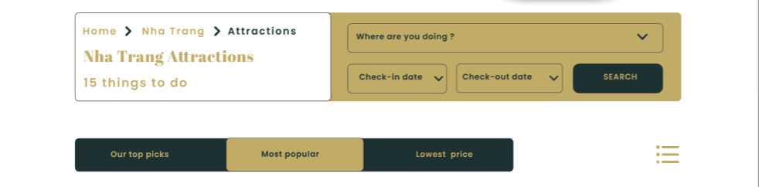

-You can search for the tour you want that suits your time and money here

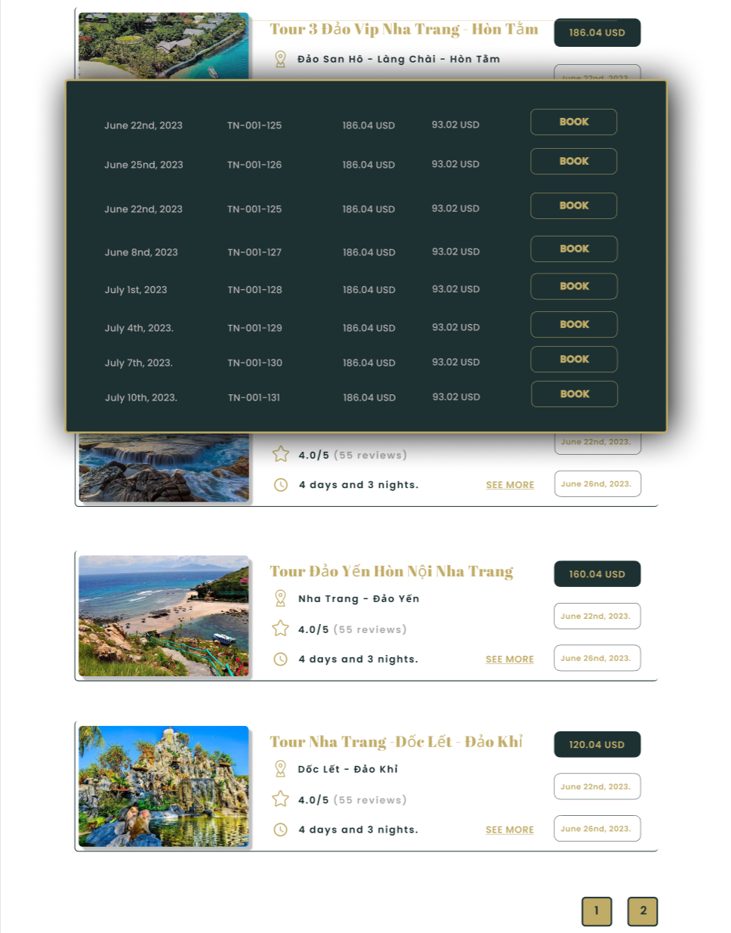

-See the tour you are looking for here, click book to proceed with your booking

### 

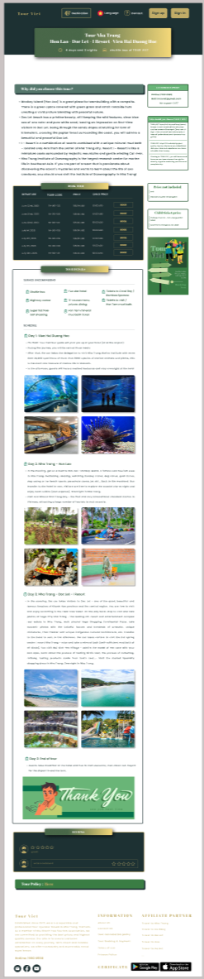

-Before proceeding to book a tour, you will be able to see the schedule of that tour

## 1.3Policy:

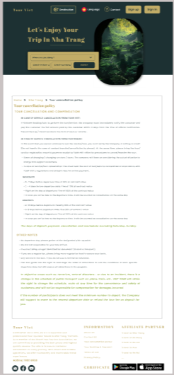

-You can see the company's policy if you choose that tour to ensure the rights of users when traveling

## 1.4 Service:

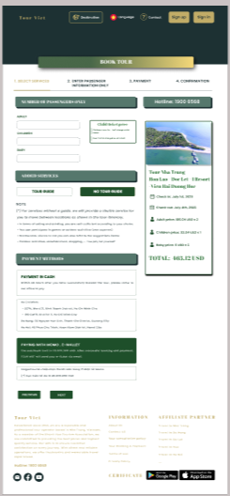

-Book a tour here

## 1.5 Passenger:

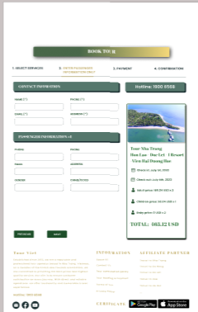 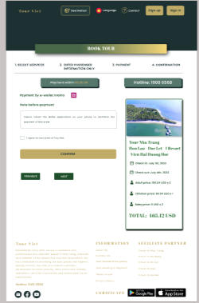

-Booking tour right here

1.6 Sign In:

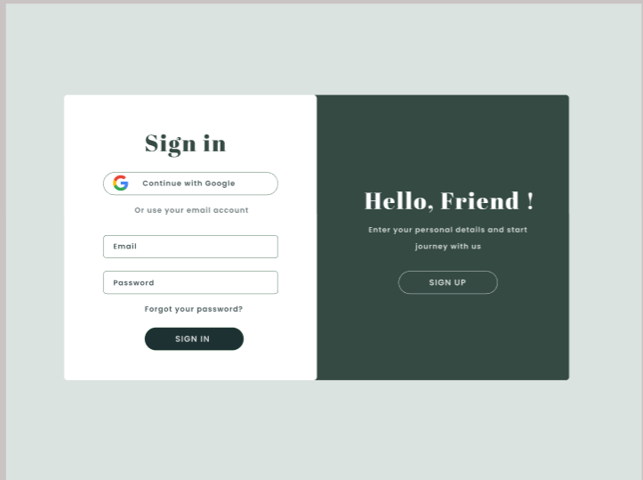

-Login here

1.7 Sign Up

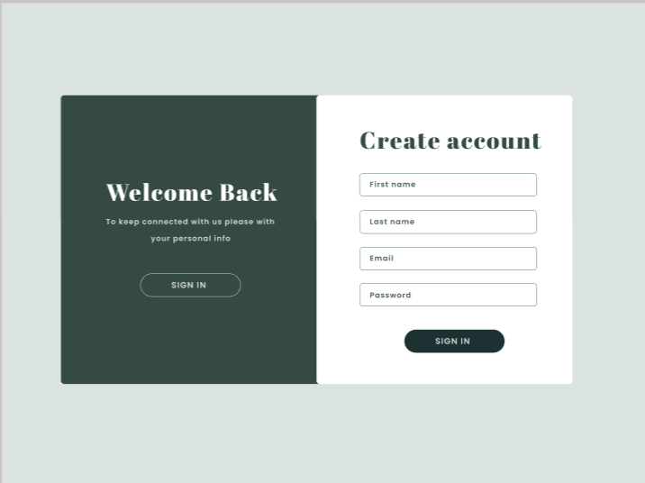

-Sign Up here

1.8 Dialog

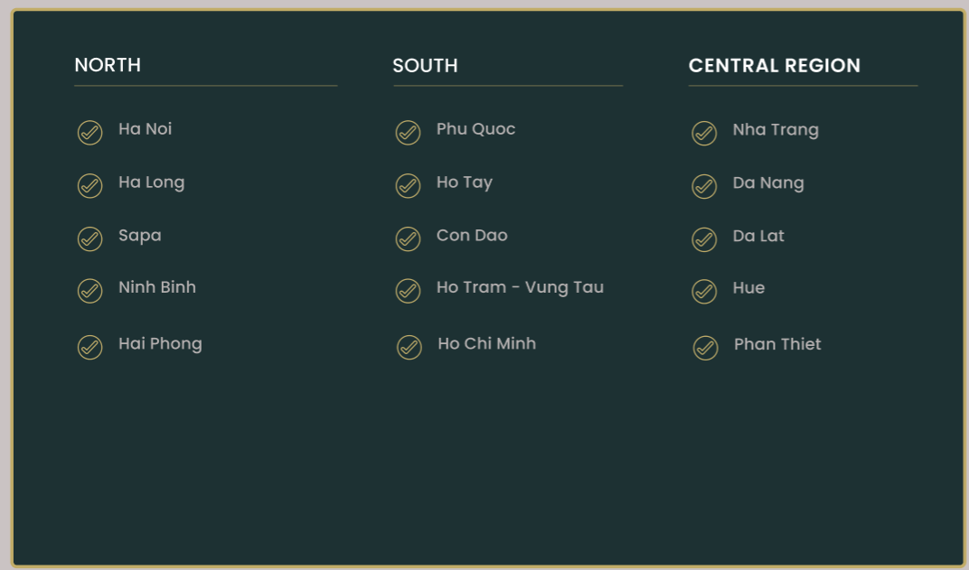

1.9 Language

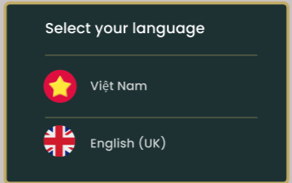

-Your option language

# **2. Mobile GUI Design**

## 2.1 Welcome



-Welcom to App TourViet



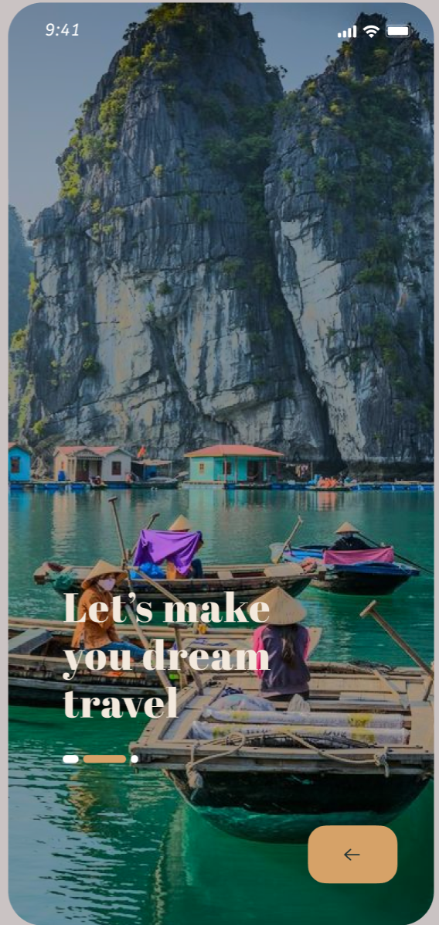

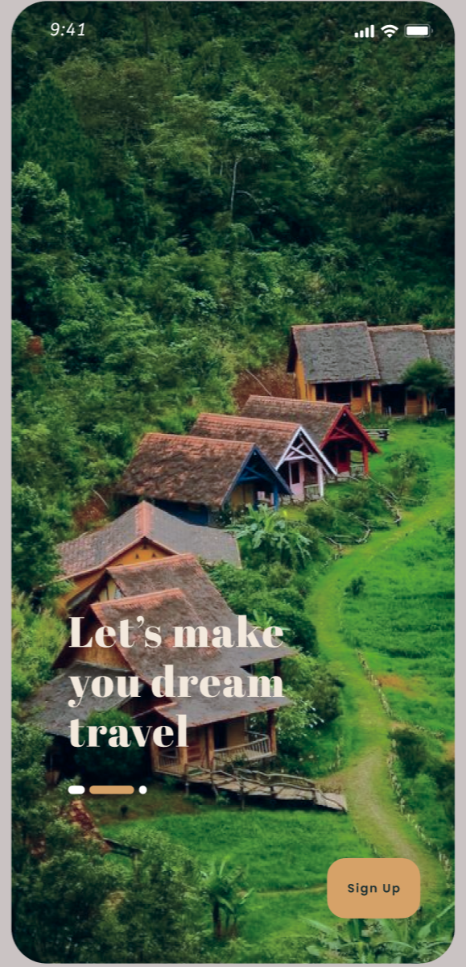

## 2.2 Login

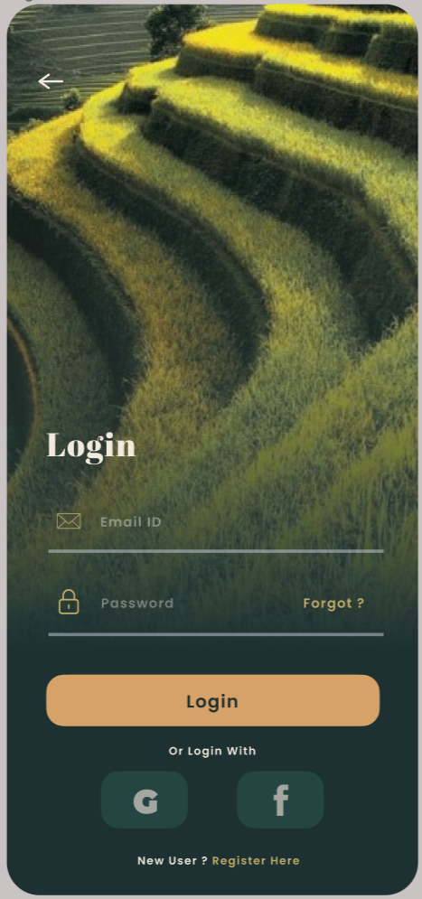

-Login here, you can login gmail or facebook

## 2.2 Login with register account

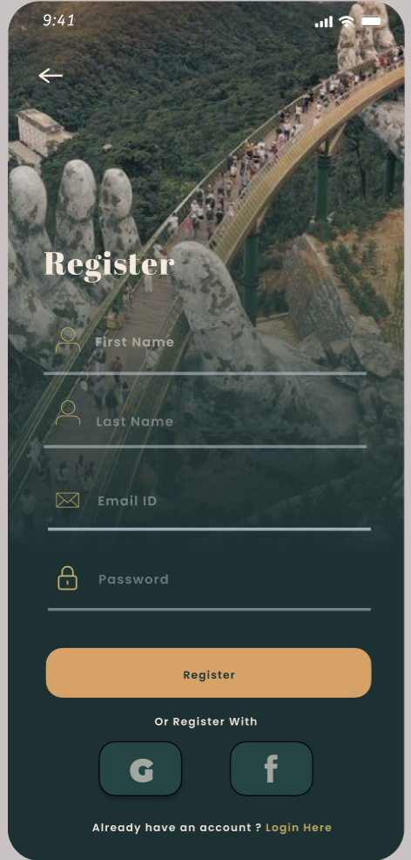

- If you don’t account , you can create account in register

2.2 Verify Account

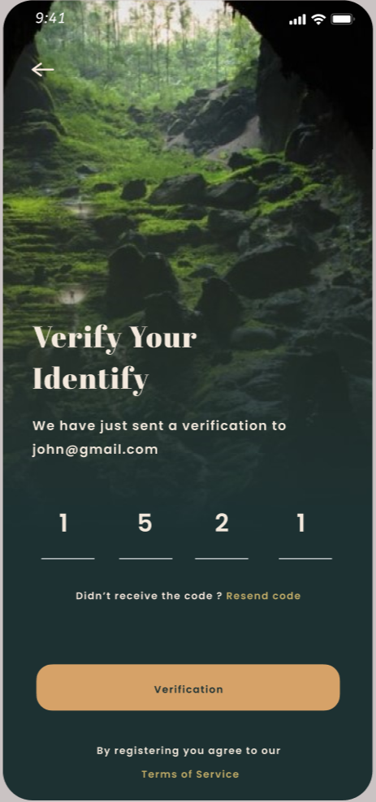

-After you register success, you need to verify code at your email . If not you can’t use your account

## 2.3 Forgot Password

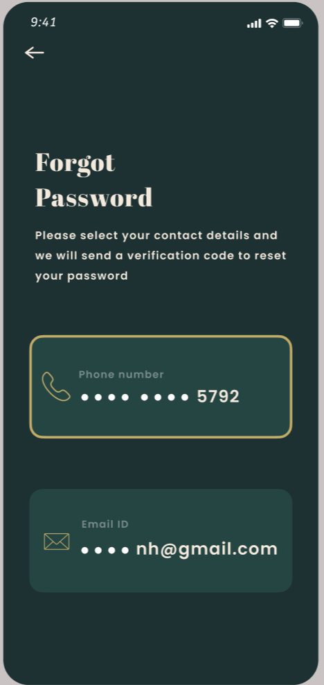

-If you forgot password , you can reset password here. We will send code for email or your phone

## 2.3.1 Verify Password

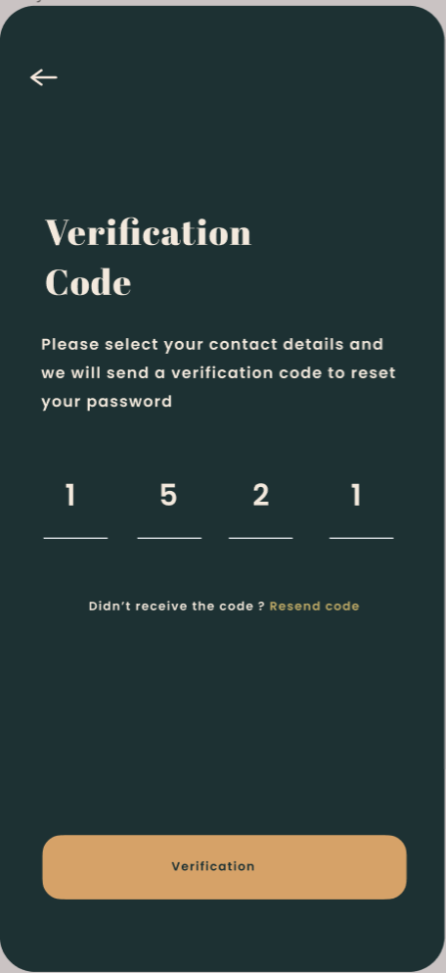

-Enter verify code here

## 2.3.2 Reset Password

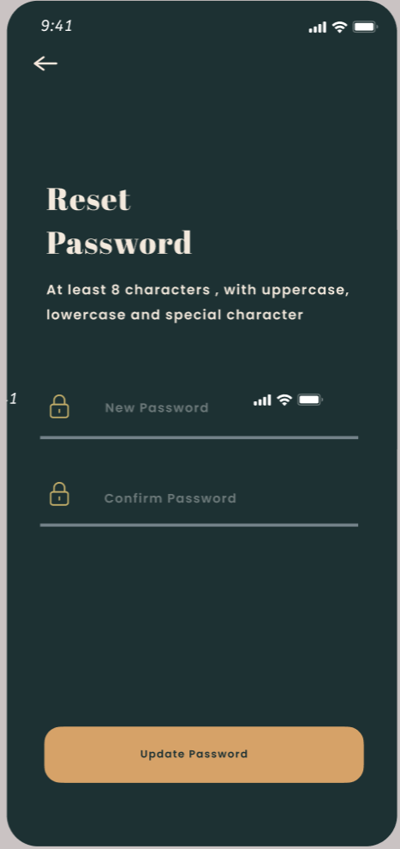

-Enter your new password

2.4 Term Of Service

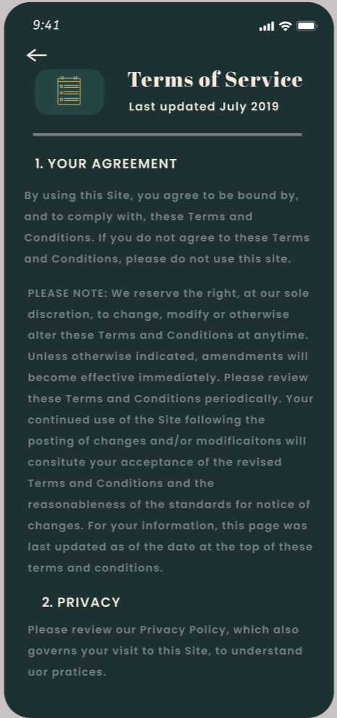

-This is our Term of service and you can watch before use our app

2.5 Account

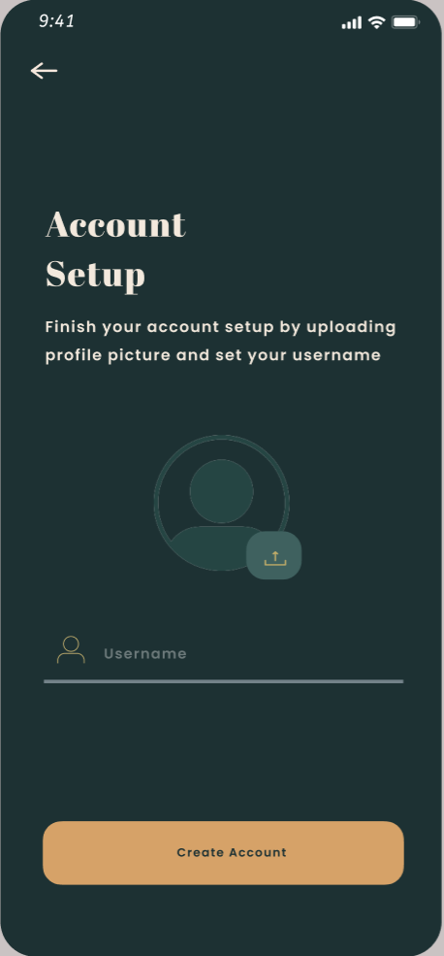

-Enter username and upload your avatar

2.5.1 Account for Username Empty

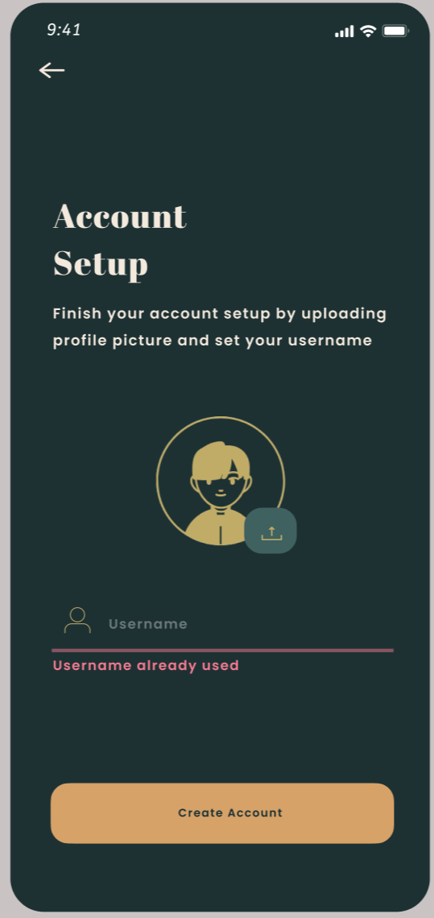

-If you don’t enter here, It will notification like it

2.5.2 Account Success

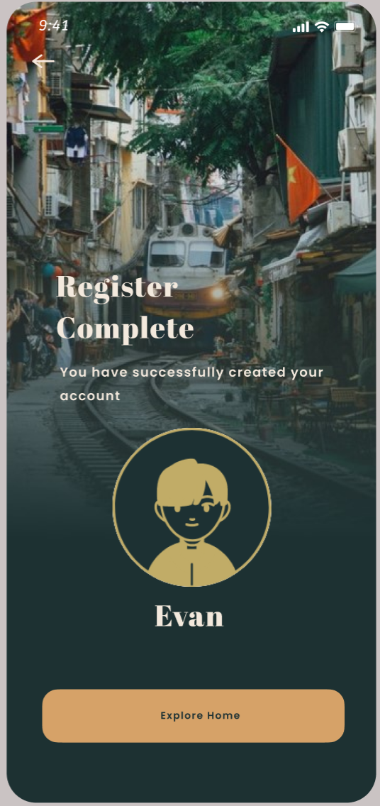

-You used our app TourViet

2.6 Home

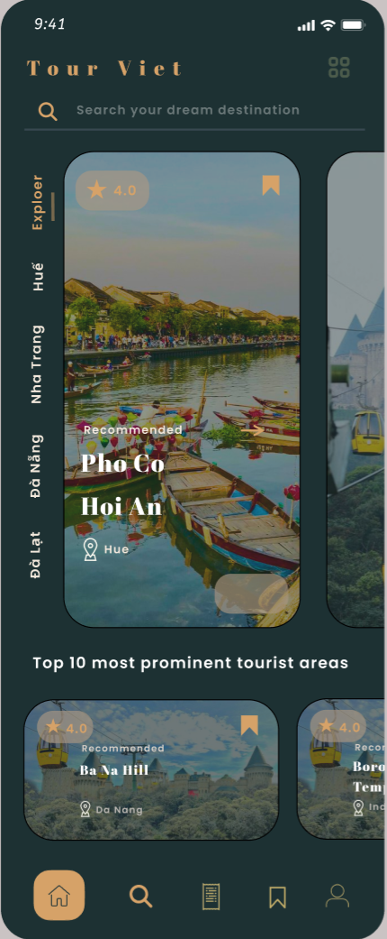

-At Home, We have Explore , search, account,…

-At Explore , you can booking tour

-You can search tour want to you here

-You can click on Account for edit profile

2.7 Central Region

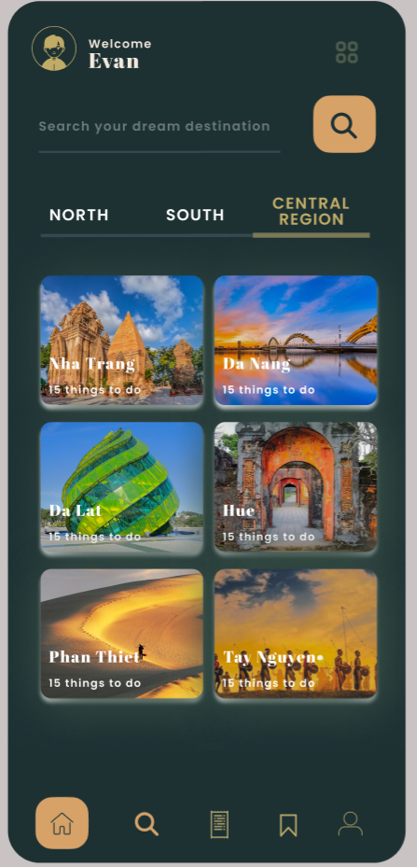

-This is tour in central tour in VietNam

2.8 Search Tour

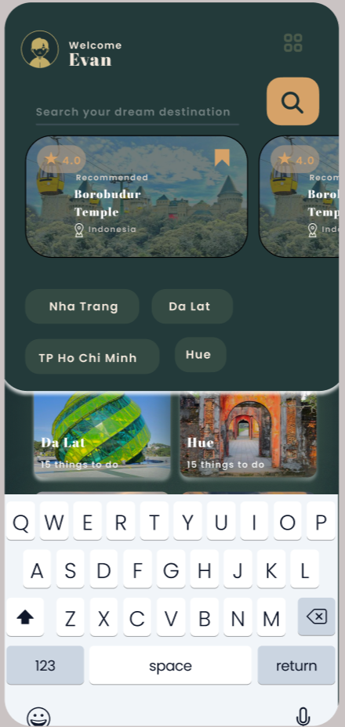

-You search tour here

2.8.1 Search Tour Not Found



-If you search tour don’t find, It will notification not found

2.9 Filter

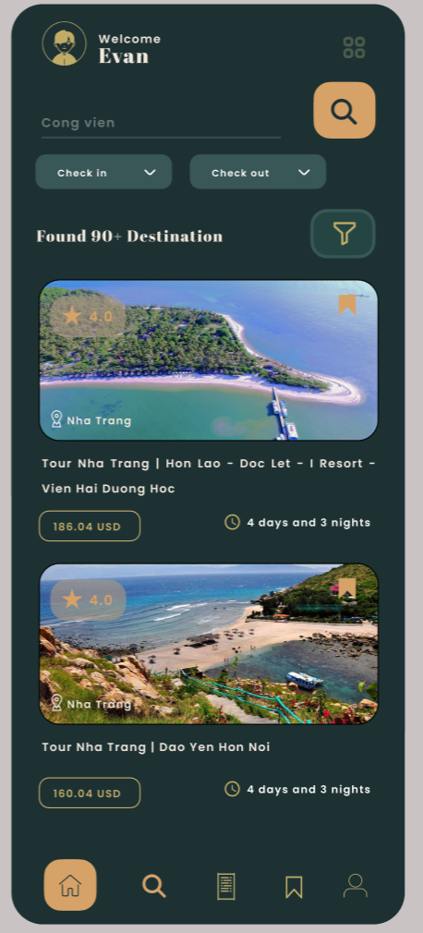

-You can Filter your tour for money or date time

2.9.1 Filter

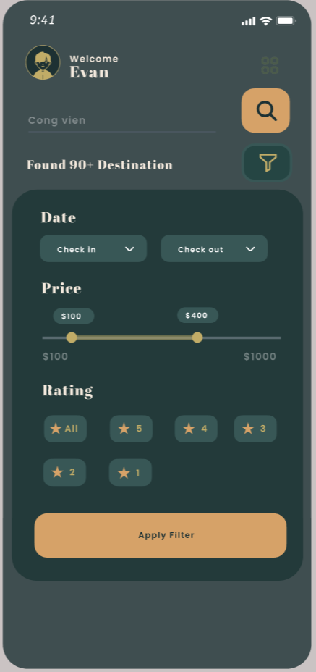

-You can search for rate 1 to 5

3.0 Explore

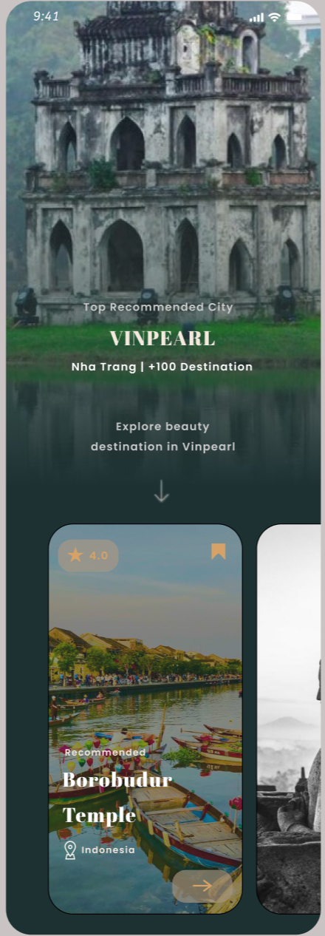

3.1 Distination

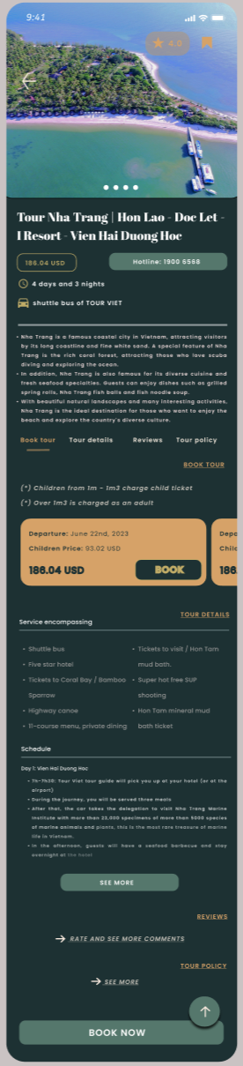

-You can booking tour here

3.1 Schedule

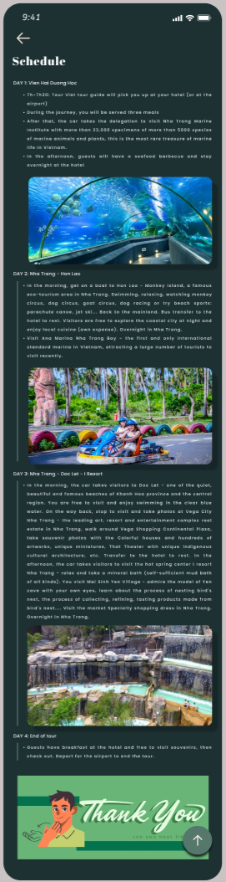

-This is schedule for tour

3.3 Policy

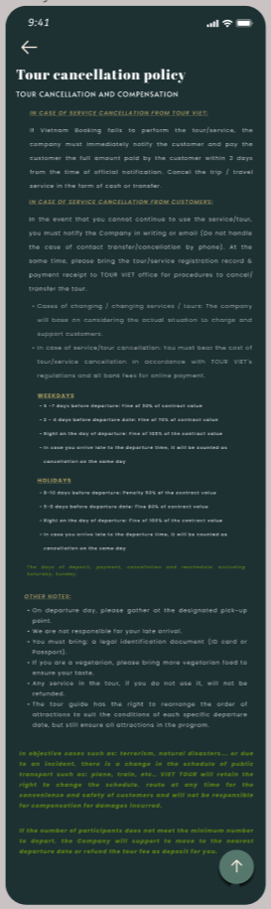

-You can check our policy before booking tour

4.3 Review

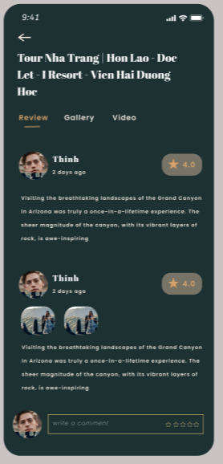

-You can watch review tour here

3.4 Gallery

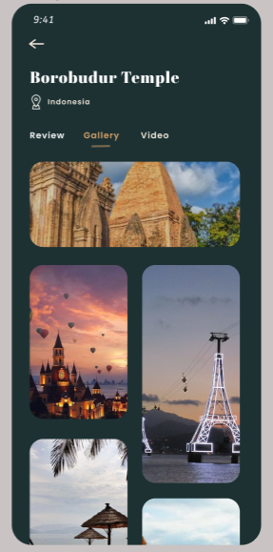

-This is our Gallery

3.4 Gallery

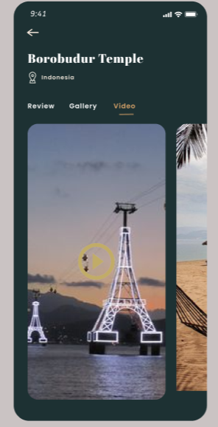

-At Gallery, you can watch video tour

3.4 Create Booking

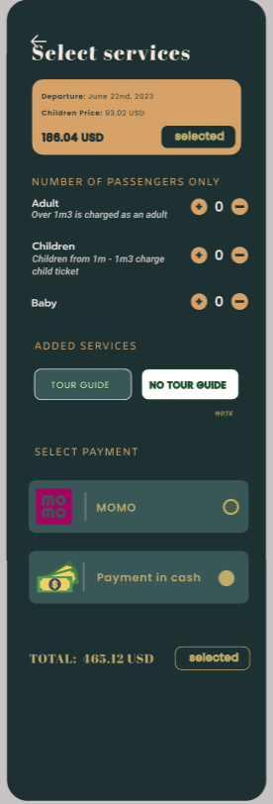

-Please Enter Information do booking tour here

3.5 Note

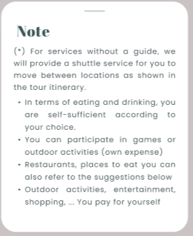

3.6 Payment

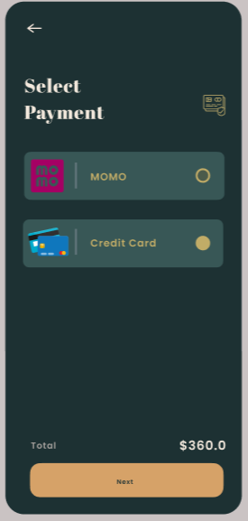

-You can choose 2 option Payment:  
+Momo  
+Credit Card

3.6.1 Booking Success

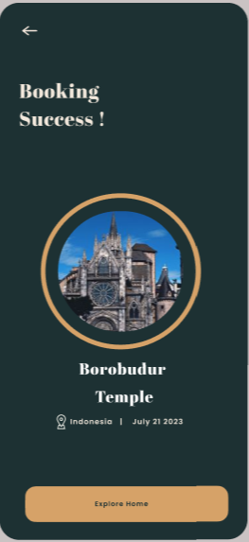

-Your tour Booked success

3.6.1 Message

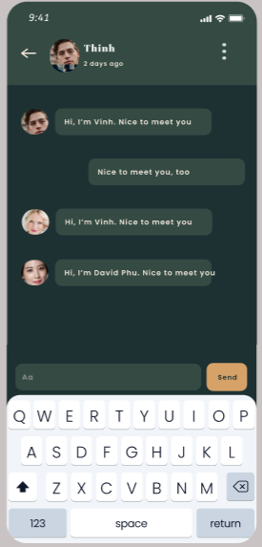

-You can inbox with your friend and you tour guide here

3.7 Profile

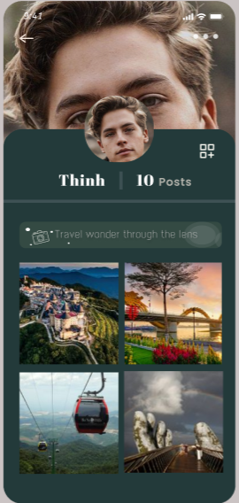

-Other people can see your profile and this is what they can see

3.7.1 Profile

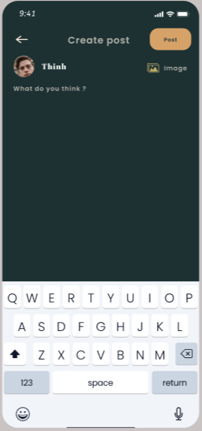

-You can post here

3.7.2 Profile

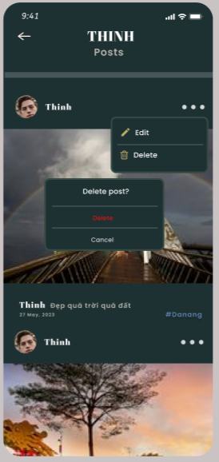

-This is your person page

3.7.3 Edit Post

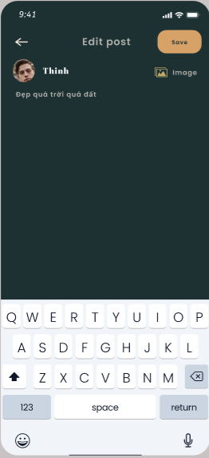

-You can edit post here and if click on “Save” it will update success

3.7.5 Profile

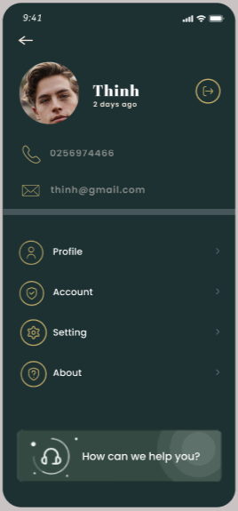

-After click account this is account and you can log out here

3.7.6 Profile

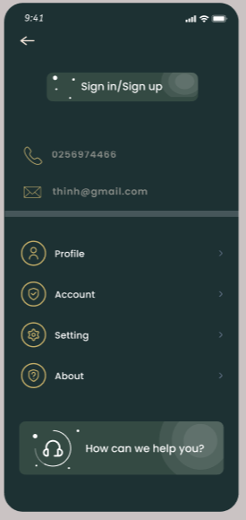

-You have 4 option:  
+Profile(IMAGE 3.7.6)

+Account  
+Setting(IMAGE 3.8.2)

+About(IMAGE 3.8.3)

3.7.6 Profile

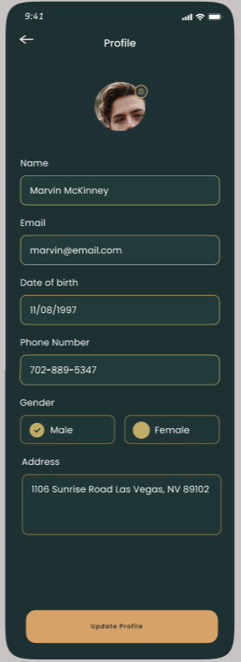

-This is your profile

3.8 Account And Setting

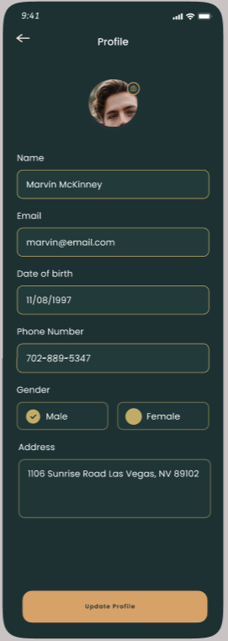

-Edit profile here

3.8.1 Update Account

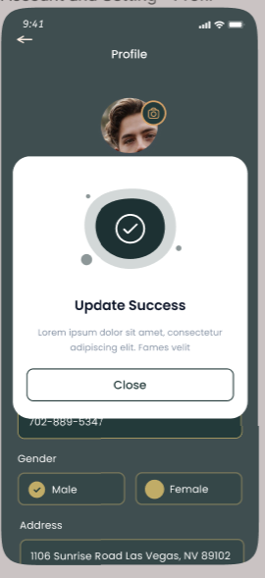

-Update profile success

3.8.1 Change Password

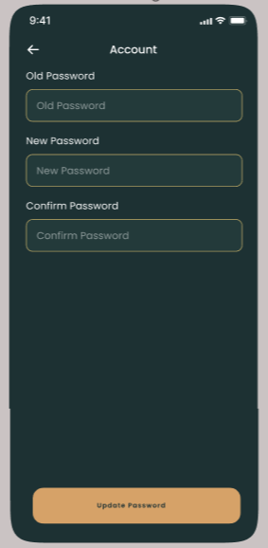

-You can change your password here

3.8.2 Settings

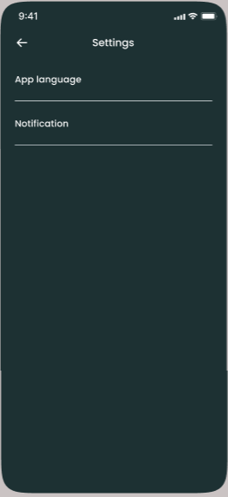

-This is your setting . You can choose App language (IMAGE 3.8.3) and Notification (IMAGE 3.9)

3.8.3 Language

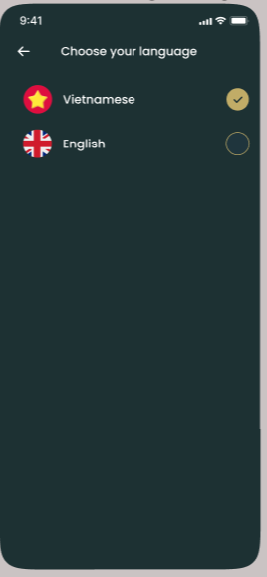

-You can choose language here

3.8.3 About Us

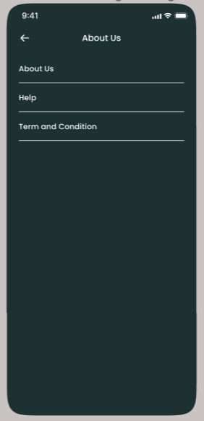

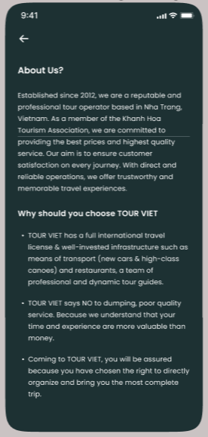

-This is our About us

3.9 Notification

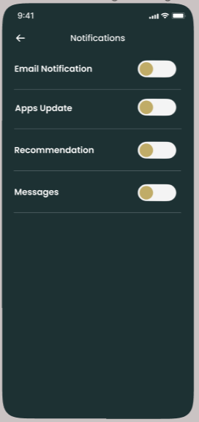

-You can turn off notification here

Task Sheet 3

|  |  |  |  |  |  |
| --- | --- | --- | --- | --- | --- |
| **Members Group** | | **Date Preparation of Activity Plan** | | | |
| **No** | **Name** | **Description Task** | **Start Date** | **End Date** | **Status** |
| 1 | Hoang Quoc Vinh | Web GUI Design |  |  | completed |
| 2 | Huynh Ngoc Thai |  |  | completed |
| 3 | Nguyen Anh Phu |  |  | completed |
| 4 | Nguyen Dinh Duc  Tran Cong Thinh | Mobile GUI Design |  |  | completed |
|  | | | | | |
| **Teacher** | | | **Team Leader** | | |
|  | | |  | | |
|  | | |  | | |